**ABSTRACT**

SM MEDICINE SHOP practices have evolved over time to become fully encompassed in all aspects of pharmacy itself. Such practices include: dispensing of drugs, consultation, drug regulation, and the sale of these drugs. There is a need for these practices to be fully enforced, and a management system introduced With software such as the Online Pharmacy Management System, which provides a platform has been provided to help with drug regulation, as well as providing ease to all parties involved. The methodology used in the implementation of the software is the Incremental Model of System Development Life Cycle, which allows room for scalability as time goes on. Creating an Online Pharmacy Management System would help in pharmacy practices for all parties involved. It is eminent that the system provides a safe, secure and verified platform for all parties which help to bridge the communication gap and provide legitimate drugs. Therefore, if all recommendations are strictly adhered to, there will be strict monitoring and regulation of how drugs are circulated and a decrease in the spread of fake drugs

**I N T R O D U C T I O N**

Problems in Pharmacy

• Handling Accounts & transactions (Payments, sales)

• Handling Stock(Available stock, Expire dates,)

• Bill issuing.

• Responsibilities of the employees (mistakes, cheatings).

That is why we are giving Pharmacy Management Solution

The main aim of the project is the management of the database of the pharmacy shop. This is done by creating a database of the available medicines in the shop. The database is then connected to the main program by using interconnection of the HTML,CSS,PHP program and the database already created.

**Methodology**

The approach that was used in the design of the system is the Incremental Model of System Development Life Cycle where the product being designed is implemented and tested incrementally. It is relatively cheap and is used for small projects. This methodology is most suitable for the project due to the project’s future requirements which would require changes in the system. This is further broken down in the use of:

1. JavaScript and Cascading Style Sheet tools for the web page components of the application

2. PHP as a server-side scripting language to compute records and information. 3. MySQL for database management.

Functional requirement

1. The admin’s privileges are role based, thereby allowing for Role based access control for security

2. Each users IP address is stored in the database for security

3. Users can view products out of stock but cannot card them to cart

5. Each user has a unique identifier

In the project, Waterfall model is followed.

**WATERFALL MODEL**

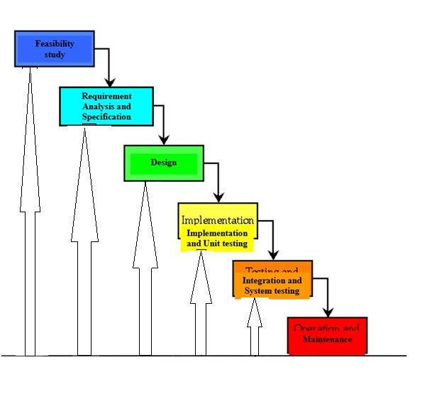

Feasibility study Requirement

Analysis and Specification

Design Implementation and Unit testing

Integration and System testing Maintenance

WATERFALL MODEL:

This model contains 6 phases: o Feasibility study The feasibility study activity involves the analysis of the problem and collection of the relevant information relating to the product. The main aim of the feasibility study is to determine whether it would be financially and technically feasible to develop the product. o Requirement analysis and specification The goal of this phase is to understand the exact requirements of the customer and to document them properly.(SRS) o Design The goal of this phase is to transform the requirement specification into a structure that is suitable for implementation in some programming language. o Implementation and unit testing During this phase the design is implemented. Initially small modules are tested in isolation from rest of the software product. o Integration and system testing In this all the modules are integrated and then tested altogether. o Operation and maintenance. Release of software inaugurates the operation and life cycle phase of the operation. The phases always occur in this order and do not overlap.

**System analysis and design**

The requirement specifications from the first phase are studied in this phase and the system design is conducted. Analysis of existing system is also carried out in this phase; the limitations of the existing system are analyzed and improved upon. System analysis and design, The requirement specifications from the first phase are studied in this phase and the system design is conducted. Analysis of existing system is also carried out in this phase; the limitations of the existing system are analyzed and improved upon.

**System Requirements**

The system services and goals are established by consultation with system user. They are then defined in details and serve as a system specification. System requirement are those on which the system runs.

**Hardware Requirements:**

* Computer with either Intel i3 processor or AMD processor.
* 512MB DDR RAM
* 40GB hard disk drive

**Software Requirements:**

* Windows 10/8/7 operating system.
* Microsoft Office package.
* Sublime Text
* Notepad ++
* WAMP SERVER

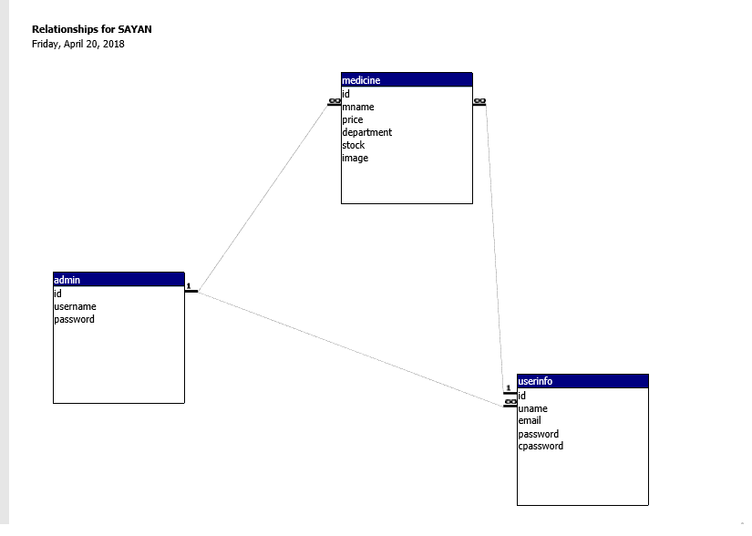

**Table Structures and Uses of Tables**

`id` (Primary Key)NOT NULL , AUTO_INCREMENT

|  |  |  |  |
| --- | --- | --- | --- |
| admin | `id` int(11) | `username` varchar(50) | `Password` varchar(8) |

|  |  |  |  |  |  |
| --- | --- | --- | --- | --- | --- |
| medicine | `id` int(3) | `price`  Int(10) | `department` varchar(100) | `stock` int(10) | `image`  text |
| HIMALAYA COUGH SYRUP | 1 | 50 | Cough Aids | 20 | him.jpg |
| ALEVED | 2 | 1247 | Cold Relief | 10 | aleved.jpg |
| DIGEST | 5 | 599 | Digestives & Laxatives | 4 | digest.JPG |
| BOROLINE | 3 | 390 | Antiseptics | 50 | boroline.jpg |
| DETTOLE | 4 | 106 | First Aid Kits | 15 | dettol2.jpg |
| DISPRINE | 6 | 40 | Pain Relief | 100 | disprine.jpg |
| FACE PRODUCT | 7 | 150 | |  |  | | --- | --- | | Body Cream & Lotion |  | | 250 | faces.jpg |
| GELUSIL | 8 | 78 | Digestives & Laxatives | 30 | Gelusil.png |
| VIAGRA | 9 | 417 | Health Protection | 10 | viagra.jpg |
| NEEM OIL | 10 | 74 | Health Protection | 20 | neemoil.jpg |
| POLYCROL | 11 | 125 | Digestives & Laxatives | 35 | polycrol.jpg |

|  |  |  |  |  |  |  |  |  |
| --- | --- | --- | --- | --- | --- | --- | --- | --- |
| id | Name | Lname | Email | Password | address | Mobile | gender | dob |
| 13 | abc | abc | [abc@mail.com](mailto:abc@mail.com) | abc | Abc | 1234567890 | m | 1990-01-01 |

DESIGN

**DFD (Data Flow Diagram)**

A data flow diagram (DFD) is a graphical representation of the "flow" of data through an information system, modeling its process aspects. Often they are a preliminary step used to create an overview of the system which can later be elaborated. DFDs can also be used for the visualization of data processing (structured design).

**Diagram Conventions:**

**● Data Flow** Data flow

Process Box

**●Process**

USER

**●External Entity**

D Data Store

**●Data Store**

**[CONTEXT LEVEL]**

ADMIN

CUSTOMER

LOGIN AUTHENTICATION

STATUS REQUEST CHECK INFORMATION

MEDICINE GENERATE

BILL PAYMENT BILL GENERATE

PAYMENT

**LEVEL 1**

**[LEVEL 1]**

REGISTER/LOGIN LOG IN

ADMIN

CUSTOMER

SEARCH

STATUS DETAILS

S

T

A

T

U

S

S

E

A

R

C

H

CHECK Medicine.dbf

STATUS

STATUS

Purchase

GIVE

BILL

UPDATE Purchase.dbf

RECEIVED

UPDATE Stock.dbf

STATUS

GENERATE

UPDATE

UPDATE

Sales.dbf

FETCHING DATA

PROCEED

REPORT

ENTERING INF Stock.dbf

STATISTICS

REQUEST

BILL

SUPPLY

PAYMENT

ENTERING

INFO Supplier.dbf

STATUS

PAID

PAID

REQUEST

PAYMENT ID User.dbf

INFO

PAYMENT

GENERATE

UPDATE

RETRIVED

Bill.dbf

**[LEVEL-2]**

**[ADMIN]**

**ADMIN**

LOGIN

STATUS

SENDING INFO

SELECT

MANAGE SALES DETAILS

MANAGE STOCK DETAILS

MANAGE SYSTEM ADMIN

MANAGE MEDICINE DETAILS

MANAGE PHARMACY STORE

MANAGE LOGIN REPORT

ENTERING INFO SYSTEM

PROVIDE SYSTEM

CHECK

ACCESSING

INFORMATION

**[USER /CUSTOMER]**

CUSTOMER

REGISTER

/SEARCH **User.dbf**

UPDATE

SENDING NEW DATA

CHOOSE

PAYMENT

OPEN DASHBOARD

BUY PRODUCT

LOG IN

OPEN

DASHBOARD

CHECKING

PROVIDE

**[PURCHASE]**

CUSTOMER

BUY CREATE UPDATE Purchase.dbf

FETCHING DATA

UPDATE

RETRIVING DATA

GATHERING REPORT

Stock.dbf

**[SALES]**

Purchase.dbf REPORT

Sales.dbf

INFO

Sales.dbf STATISTICS

GENERATE REPORT

STATISTICS

UPDATE

GENERATE Med_ilist.dbf

RETRIVING DATA

STATUS

ENTERNG DATA

DETAILS

GENERATE

UPDATE

Prescription.dbf

Stock_Info.dbf

**[STOCK]**

FETCHING DATA

SUPPLIER

Stock.dbf

REQUEST

PAYMENT

MANAGE

REPORT

MANAGE

GENERATER

Update

**[BILLING]**

User.dbf

PAYMENT

Member_MST.db FETCHING DATA

GENERATE

CHECK

STATUS

STATUS

CHECKING

Bonus_MST UPDATE

ADD BONUS/DISCOUNT

**ER Modeling**

In software engineering, an entity–relationship model (ER model) is a data model for describing the data or information aspects of a business domain or its process requirements, in an abstract way that lends itself to ultimately being implemented in a database such as a relational database. The main components of ER models are entities (things) and the relationships that can exist among them.

**Symbol:**

**Example:**

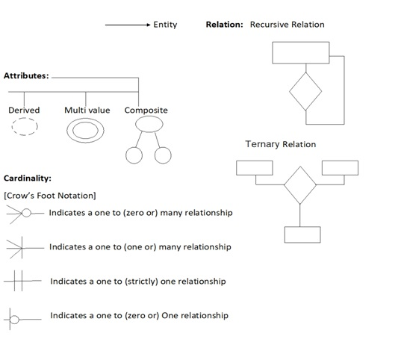

CUSTOMER

Search

Has

Check discount

CUSTOMER ACCOUNT

Bill

Generate

Payment

PRESCRIPTION

Check

Has

PAID BY

ACCOUNT

MANAGES

MANAGER

SUPPLIER

PHARMACIST

STOCK

Supply

Recorded

Sale

MEDICINE

Supply

MEDICAL STORE

Manage

ADMIN

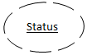

Proceed

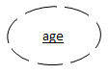

**TESTING**

Software testing is the process of executing a program with intension of finding errors in the code. It is a process of evolution of system or its parts by manual or automatic means to verify that it is satisfying specified or requirements or not. Generally, no system is perfect due to communication problems between user and developer, time constraints, or conceptual mistakes by developer. To purpose of system testing is to check and find out these errors or faults as early as possible so losses due to it can be saved. Testing is the fundamental process of software success. Testing is not a distinct phase in system development life cycle but should be applicable throughout all phases i.e. design development and maintenance phase. Testing is used to show incorrectness and considered to success when an error is detected.

#### White-box testing

White-box testing (also known as clear box testing, glass box testing, and transparent box testing and structural testing, by seeing the source code) tests internal structures or workings of a program, as opposed to the functionality exposed to the end-user. In white-box testing an internal perspective of the system, as well as programming skills, are used to design test cases. The tester chooses inputs to exercise paths through the code and determine the appropriate outputs. This is analogous to testing nodes in a circuit, e.g. in-circuit testing (ICT).

#### Black-box testing

Black-box testing treats the software as a "black box", examining functionality without any knowledge of internal implementation, without seeing the source code. The testers are only aware of what the software is supposed to do, not how it does it.Black-box testing methods include: equivalence partitioning, boundary value analysis, all-pairs testing, state transition tables, decision table testing, fuzz testing, model-based testing, use case testing, exploratory testing and specification-based testing.

##### **Visual testing**

The aim of visual testing is to provide developers with the ability to examine what was happening at the point of software failure by presenting the data in such a way that the developer can easily ﬁnd the information she or he requires, and the information is expressed clearly.

### Unit testing

Unit testing refers to tests that verify the functionality of a specific section of code, usually at the function level. In an object-oriented environment, this is usually at the class level, and the minimal unit tests include the constructors and destructors.

### Integration testing

Integration testing is any type of software testing that seeks to verify the interfaces between components against a software design. Software components may be integrated in an iterative way or all together ("big bang"). Normally the former is considered a better practice since it allows interface issues to be located more quickly and fixed.

### System testing

System testing tests a completely integrated system to verify that the system meets its requirements. For example, a system test might involve testing a logon interface, then creating and editing an entry, plus sending or printing results, followed by summary processing or deletion (or archiving) of entries, then logoff.

### Installation testing

An installation test assures that the system is installed correctly and working at actual customer's hardware.

### Smoke and sanity testing

Sanity testing determines whether it is reasonable to proceed with further testing.

Smoke testing consists of minimal attempts to operate the software, designed to determine whether there are any basic problems that will prevent it from working at all. Such tests can be used as build verification test.

### Acceptance testing

Acceptance testing can mean one of two things:

1. A smoke test is used as an acceptance test prior to introducing a new build to the main testing process, i.e., before integration or regression.
2. Acceptance testing performed by the customer, often in their lab environment on their own hardware, is known as user acceptance testing (UAT). Acceptance testing may be performed as part of the hand-off process between any two phases of development.

### Alpha testing

Alpha testing is simulated or actual operational testing by potential users/customers or an independent test team at the developers' site. Alpha testing is often employed for off-the-shelf software as a form of internal acceptance testing, before the software goes to beta testing.

### Beta testing

Beta testing comes after alpha testing and can be considered a form of external user acceptance testing. Versions of the software, known as beta versions, are released to a limited audience outside of the programming team known as beta testers. The software is released to groups of people so that further testing can ensure the product has few faults or bugs. Beta versions can be made available to the open public to increase the feedback field to a maximal number of future users and to deliver value earlier, for an extended or even indefinite period of time (perpetual beta).

### Continuous testing

Continuous testing is the process of executing automated tests as part of the software delivery pipeline to obtain immediate feedback on the business risks associated with a software release candidate. Continuous testing includes the validation of both functional requirements and non-functional requirements; the scope of testing extends from validating bottom-up requirements or user stories to assessing the system requirements associated with overarching business goals.

**OBJECTIVES OF SOFTWARE TESTING**

The software testing is usually performed for the following objectives:-

**SOFTWARE QUALITY IMPROVEMENT:-** The computer and the software are mainly used for complex and critical applications and a bug or fault in software causes severe losses. So a great consideration is required for checking for quality of software**.**

**VERIFICATION AND VALIDATION:-** Verification means to test that we are building the product in right way .i.e. are we using the correct procedure for the development of software so that it can meet the user requirements. Validation means to check whether we are building the right product or not.

**SOFTWARE RELIABILTY ESTIMATION:-** The objective is to discover the residual designing errors before delivery to the customer. The failure data during process are taken down in order to estimate the software reliability.

USER INTERFACE

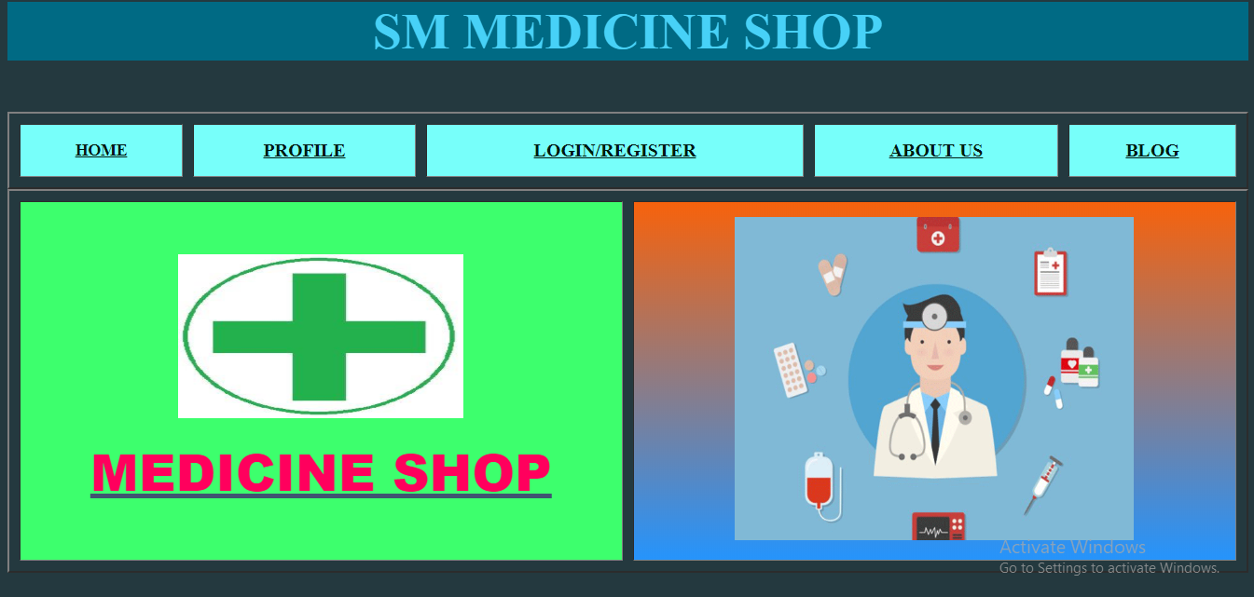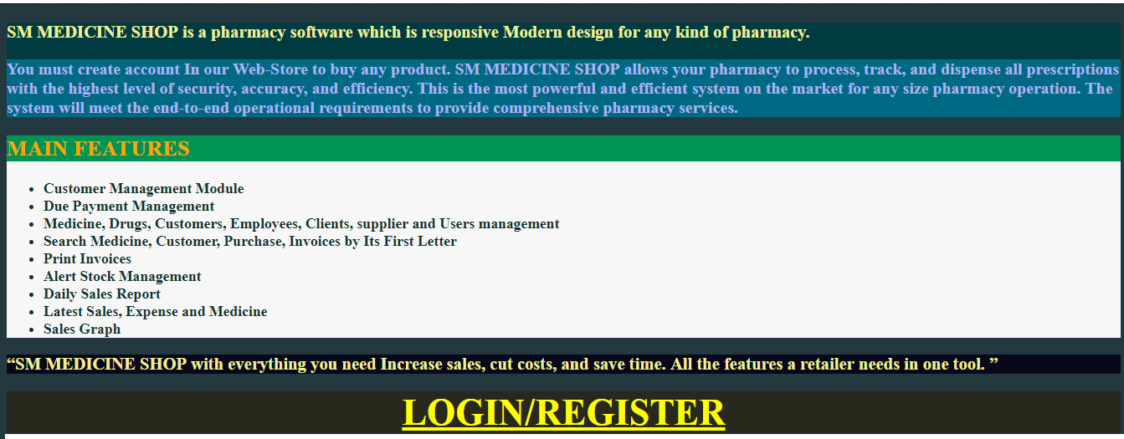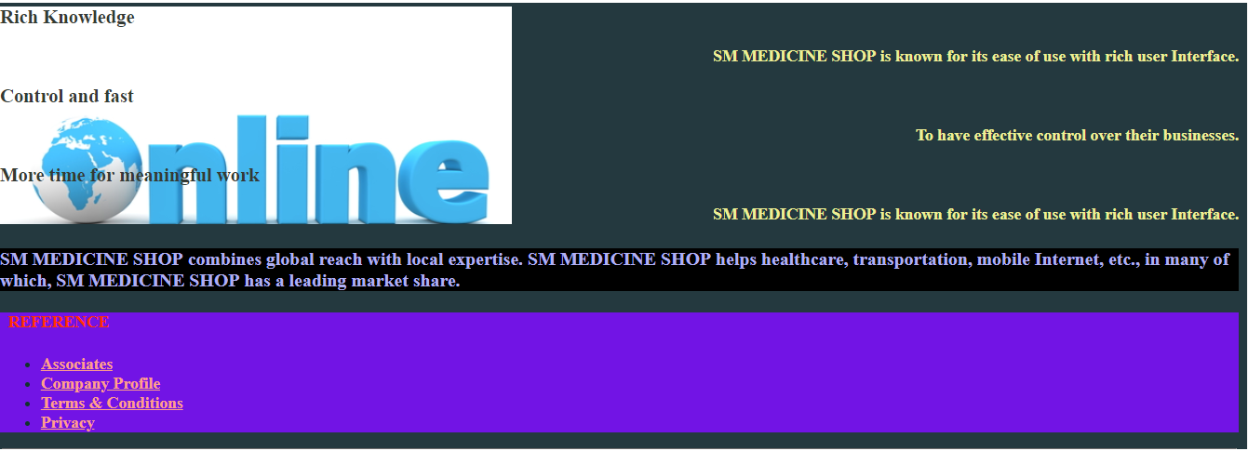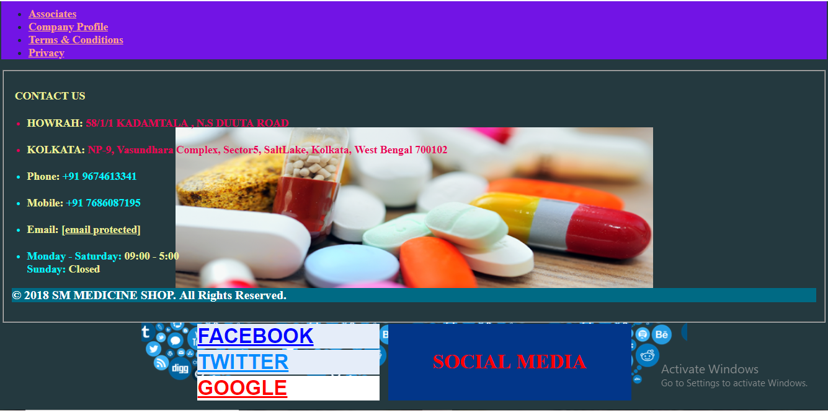

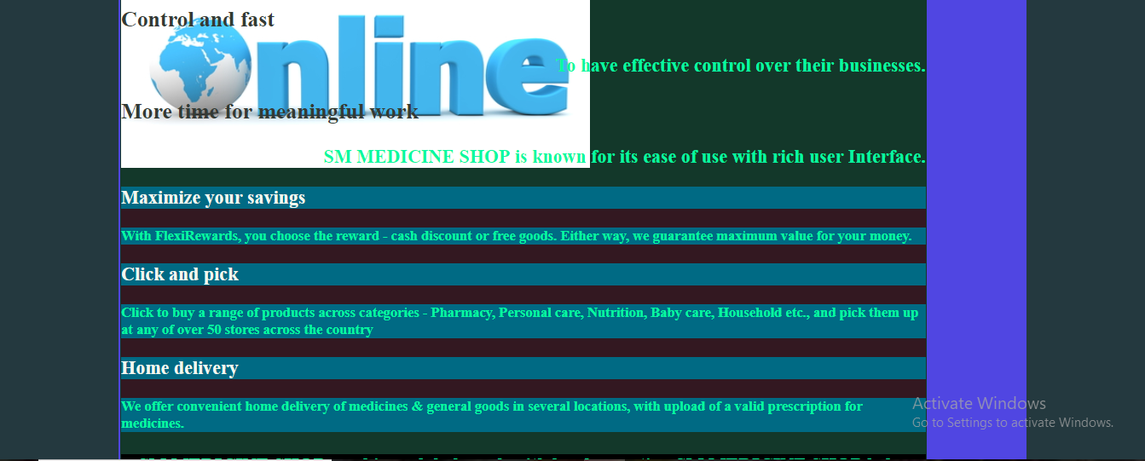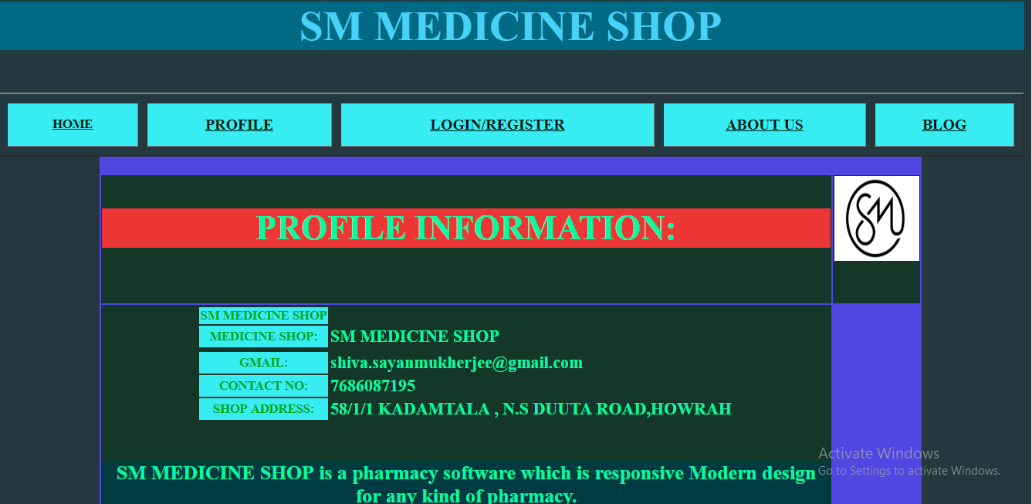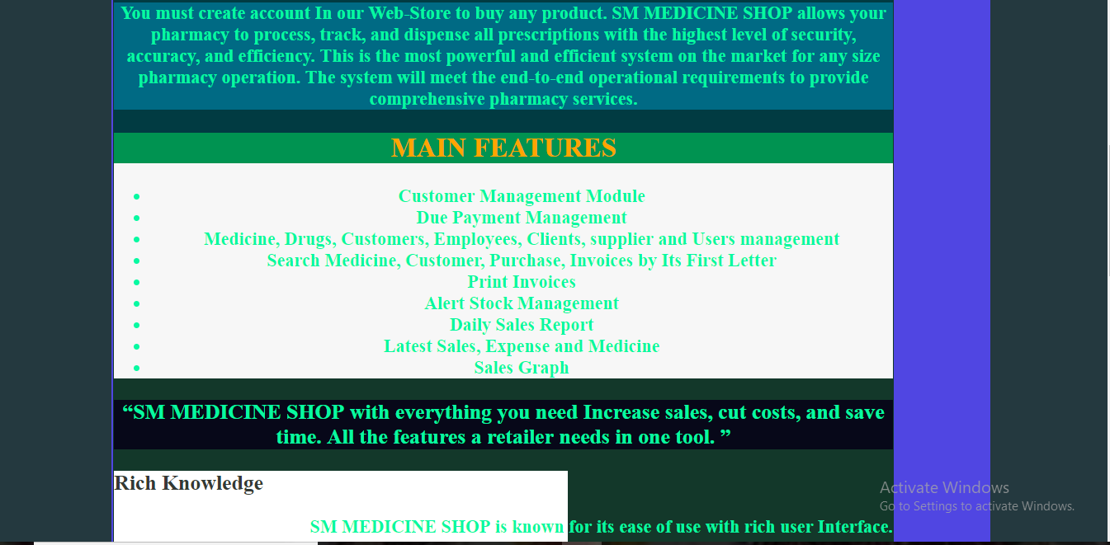

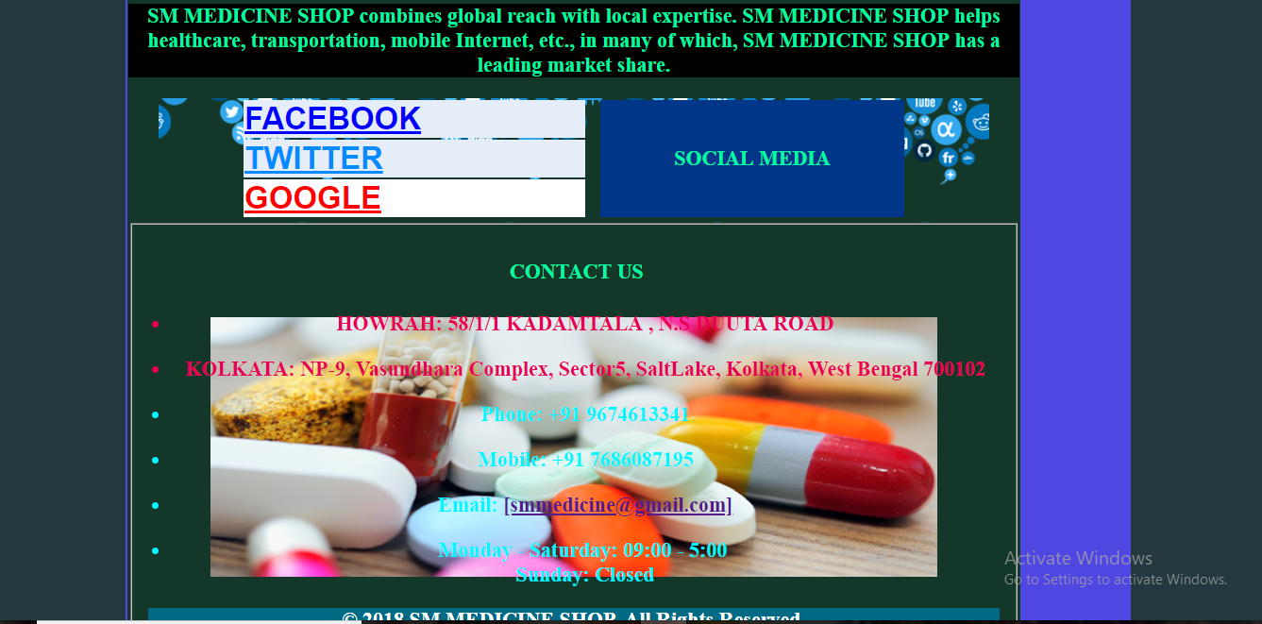

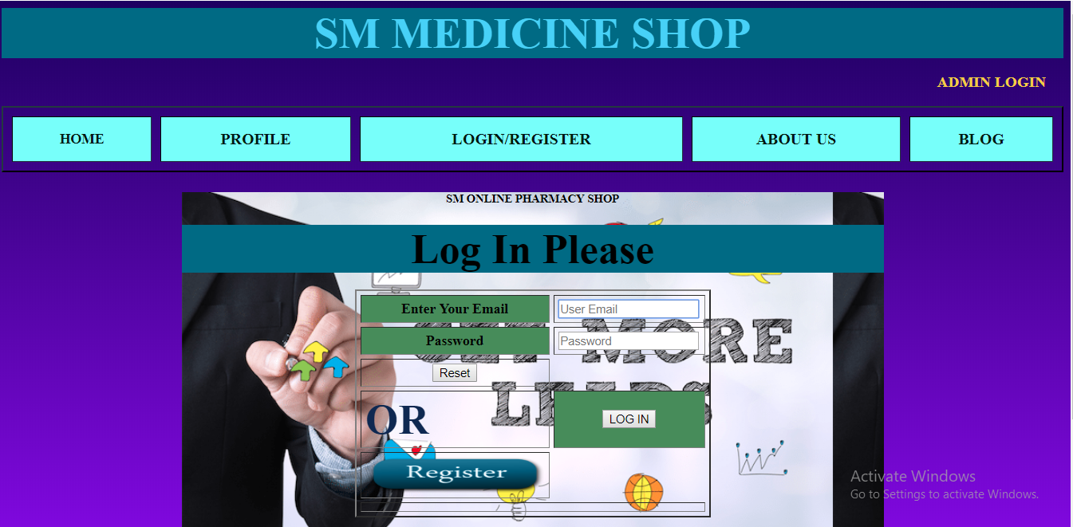

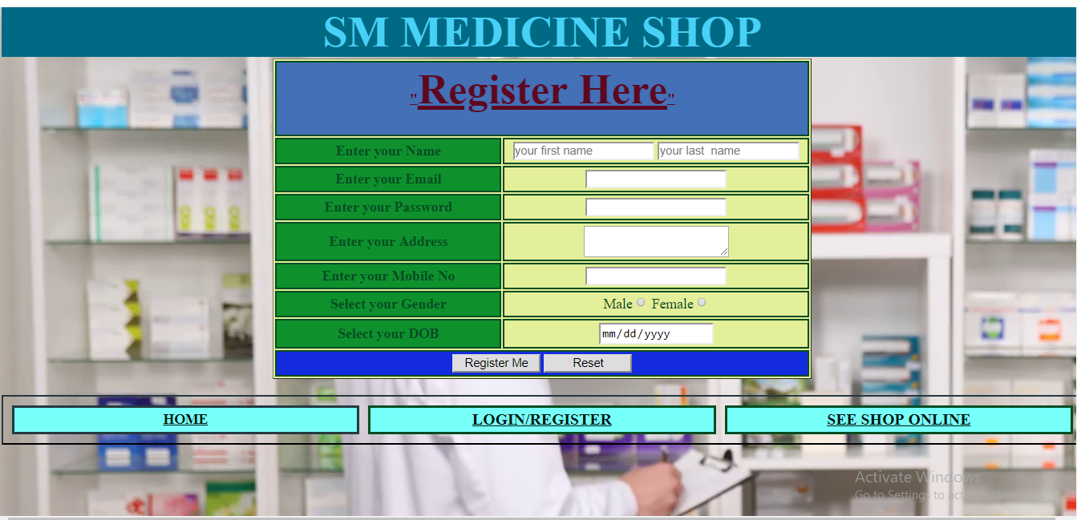

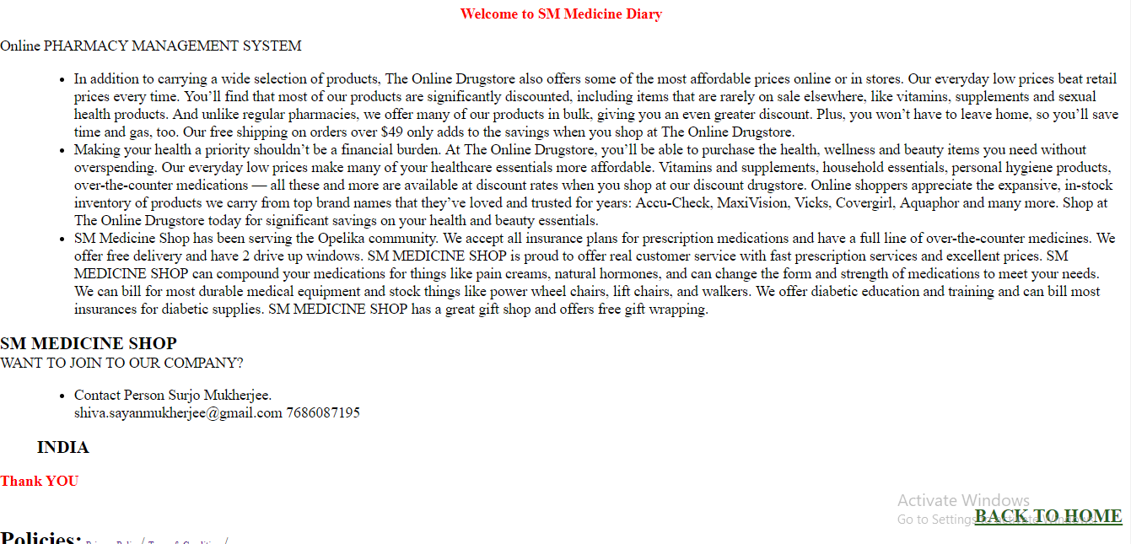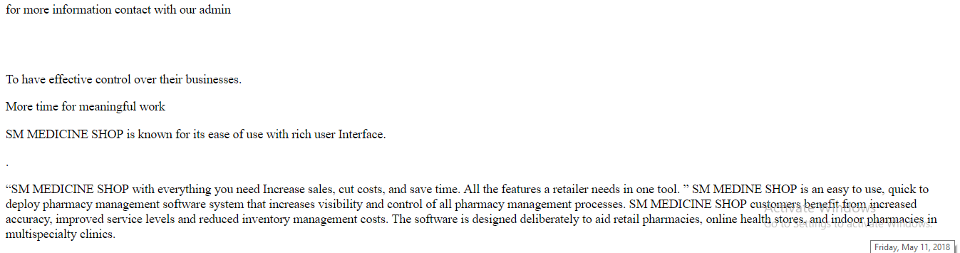

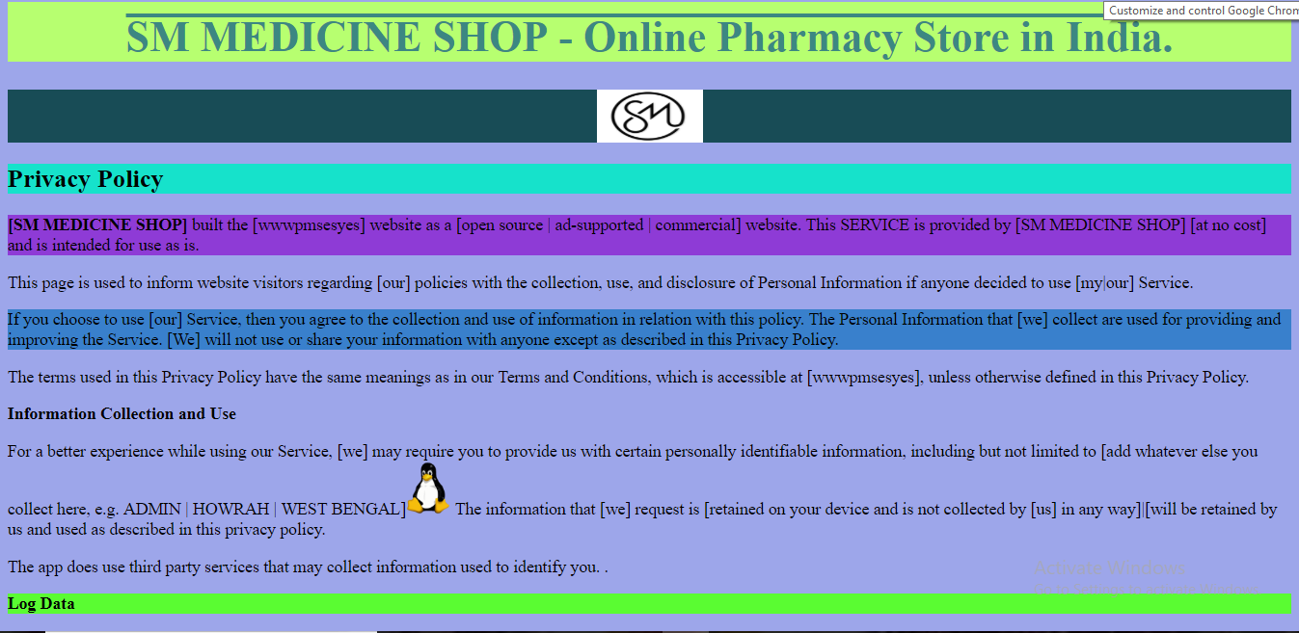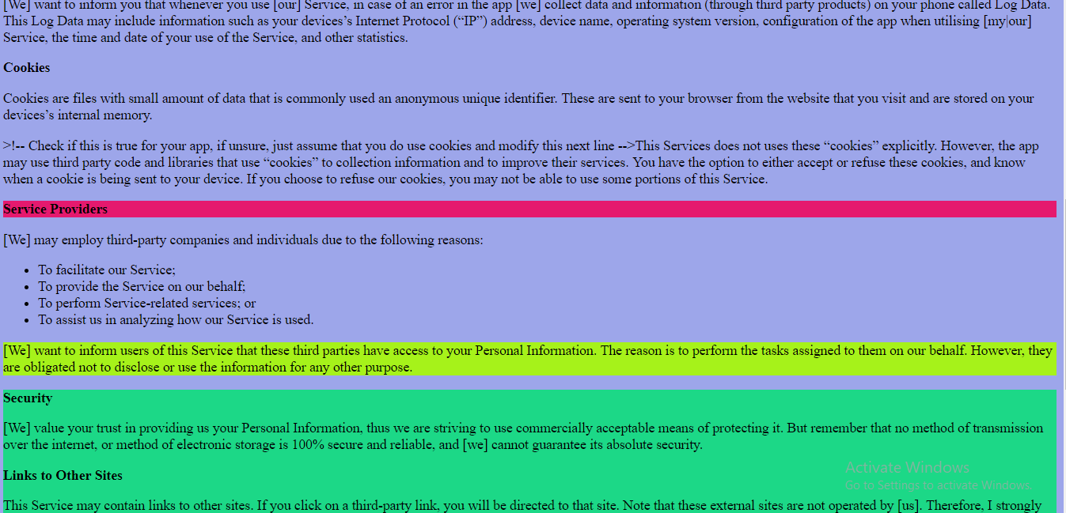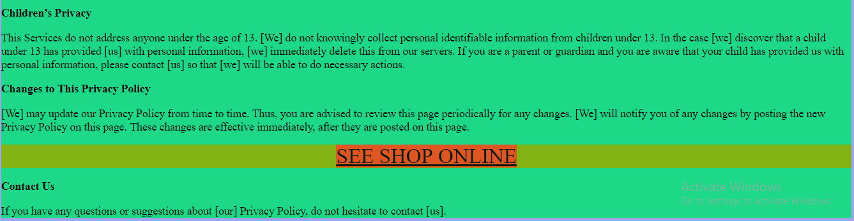

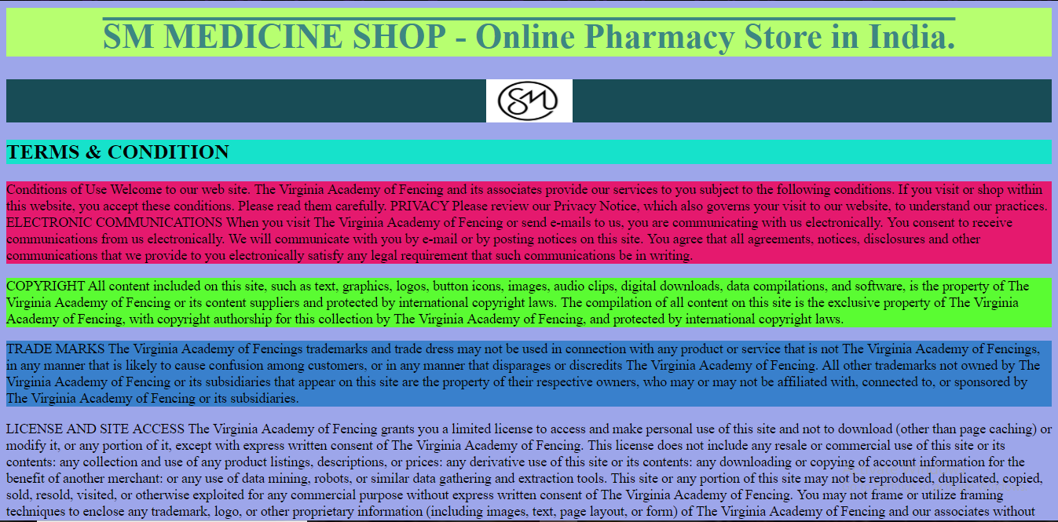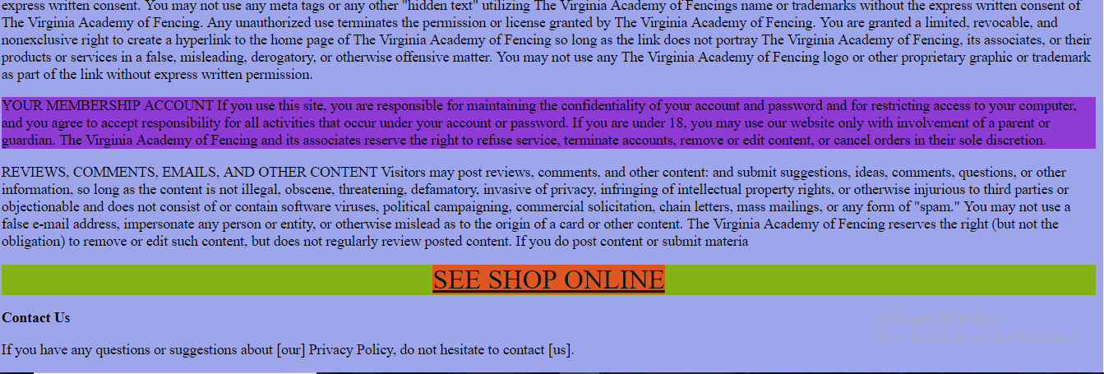

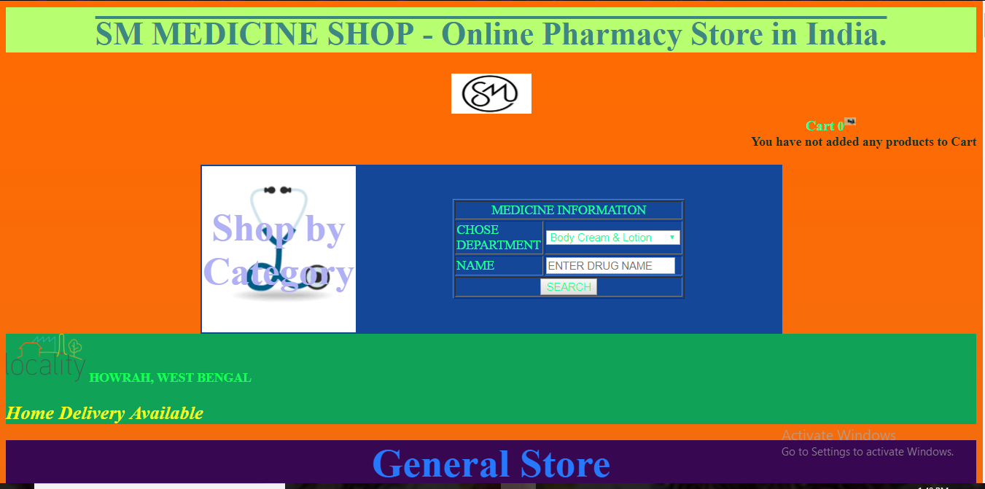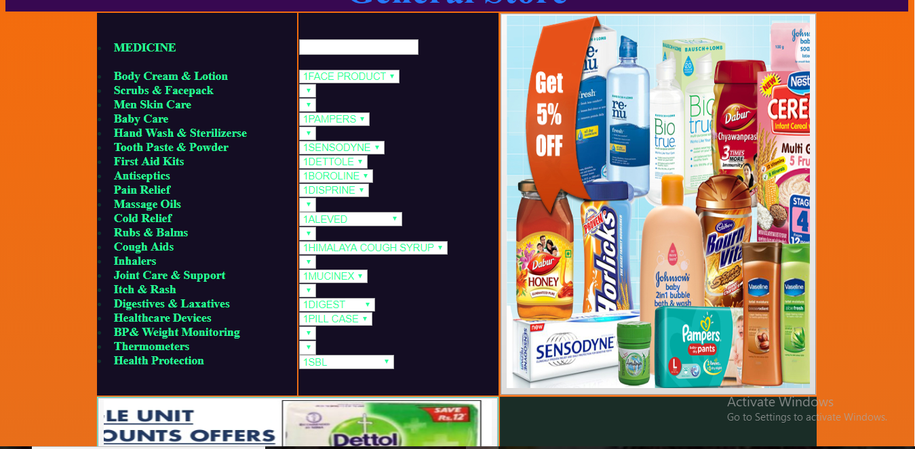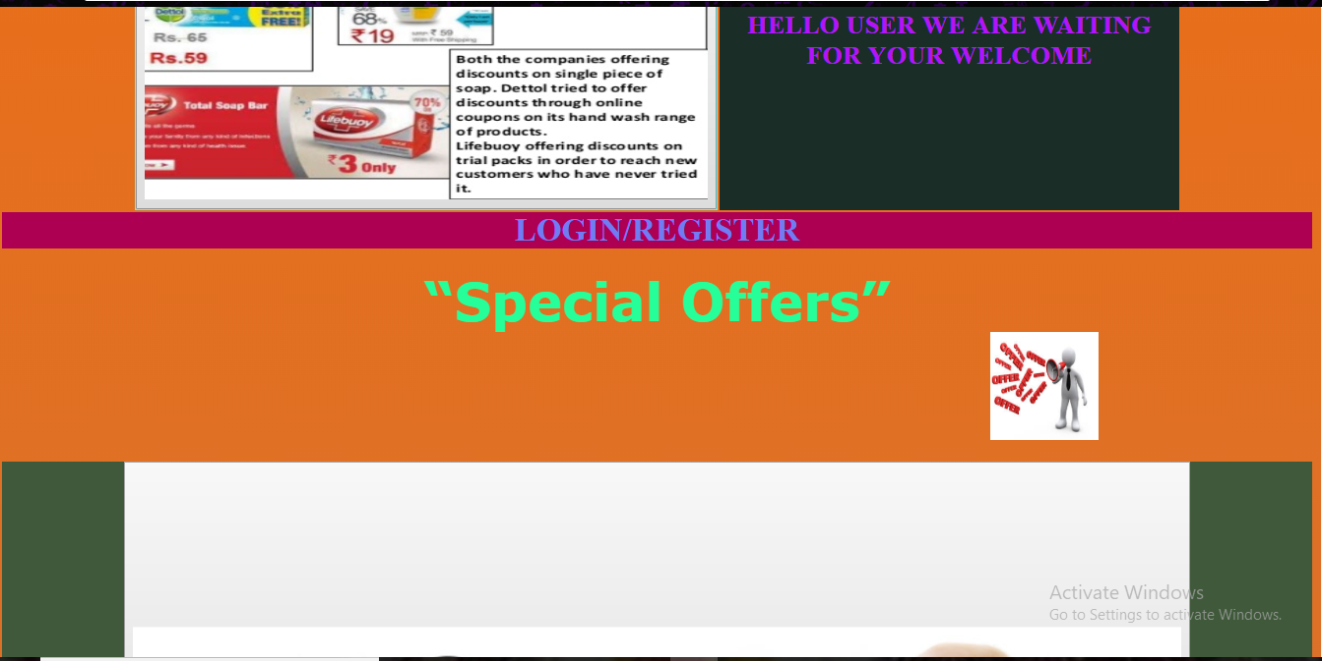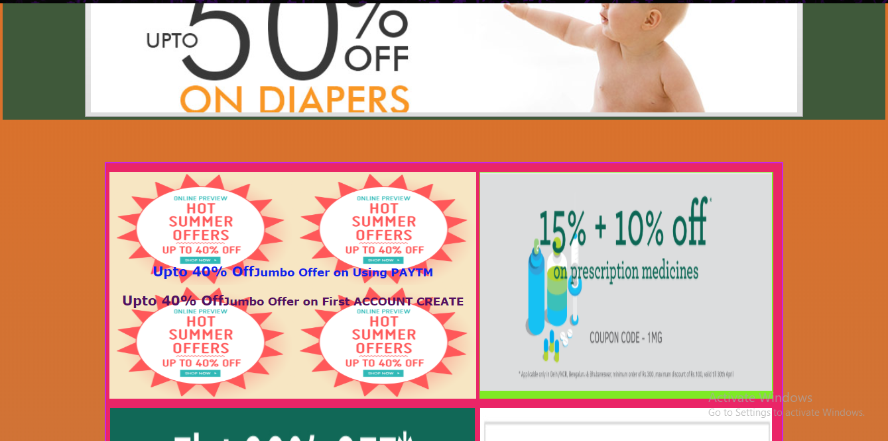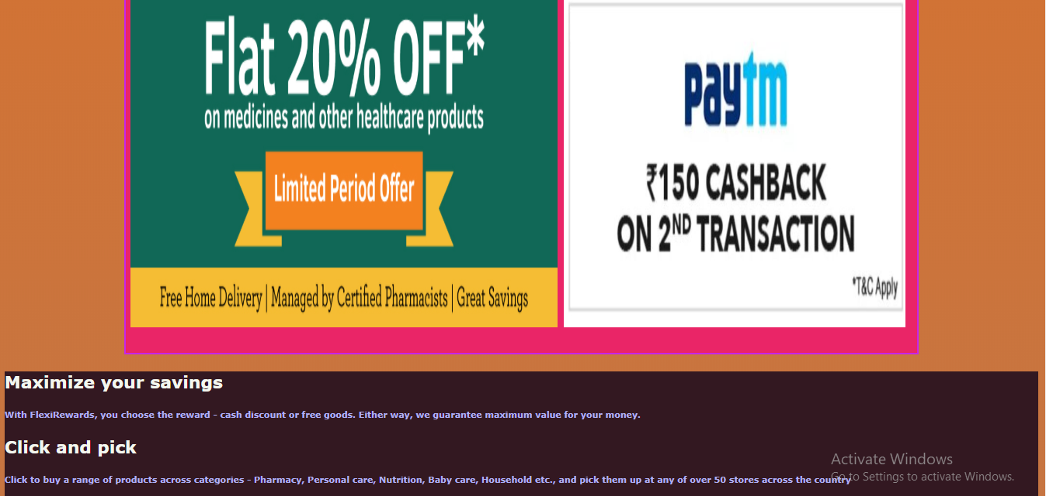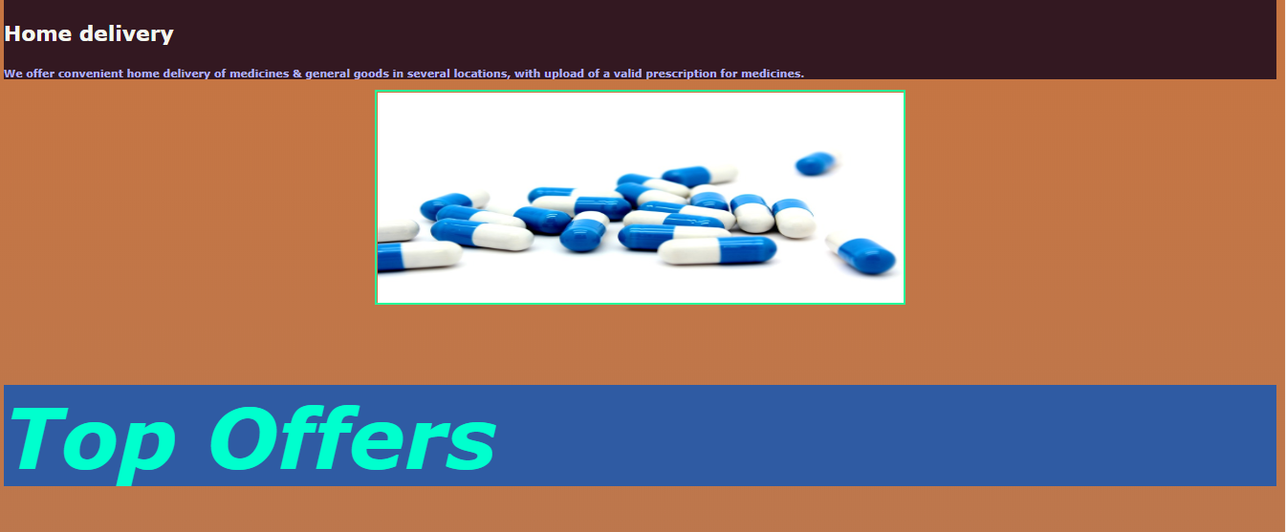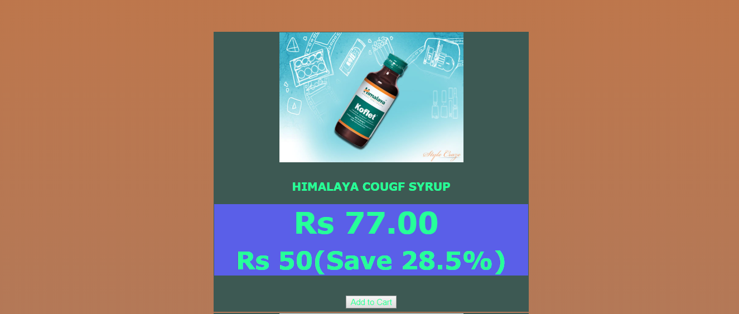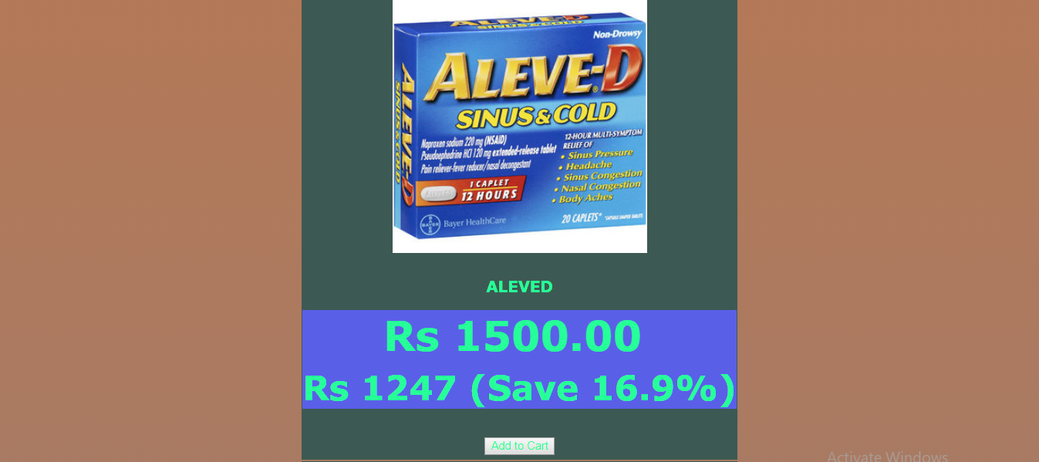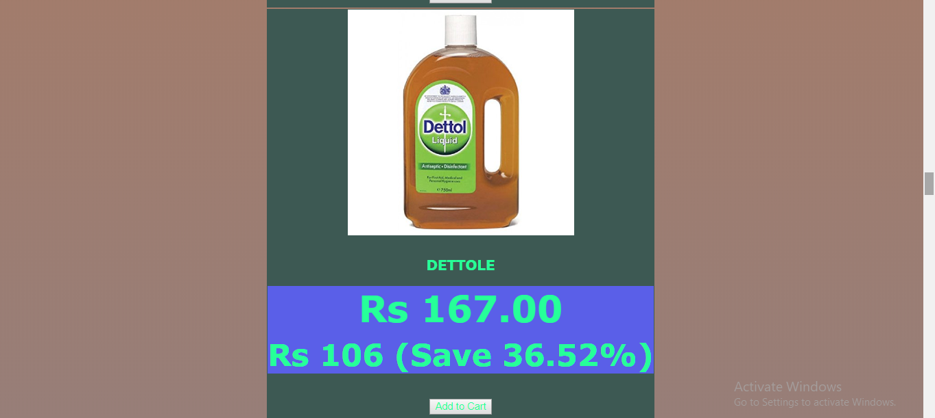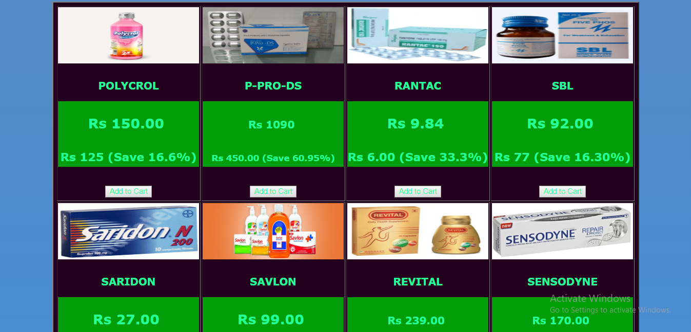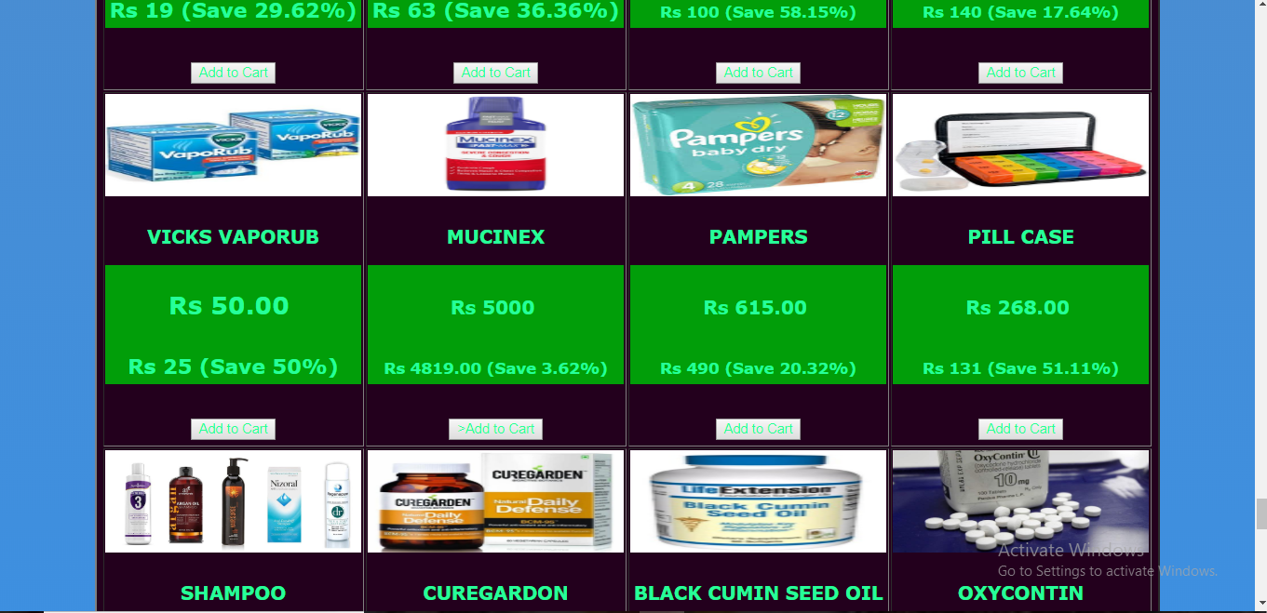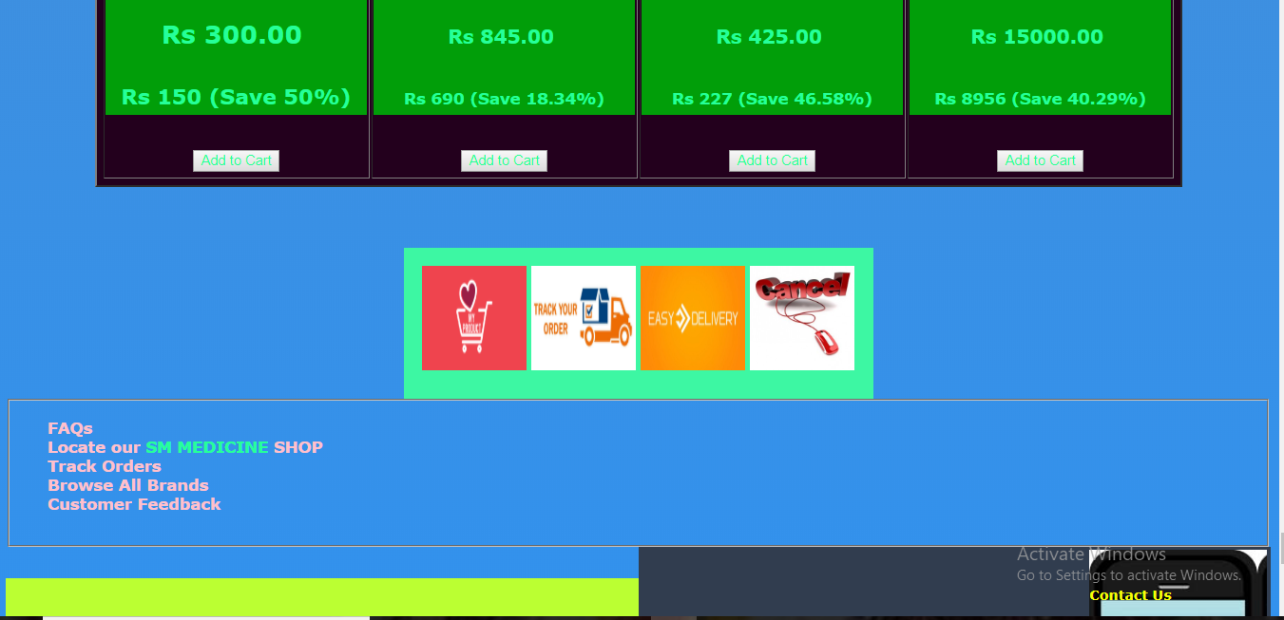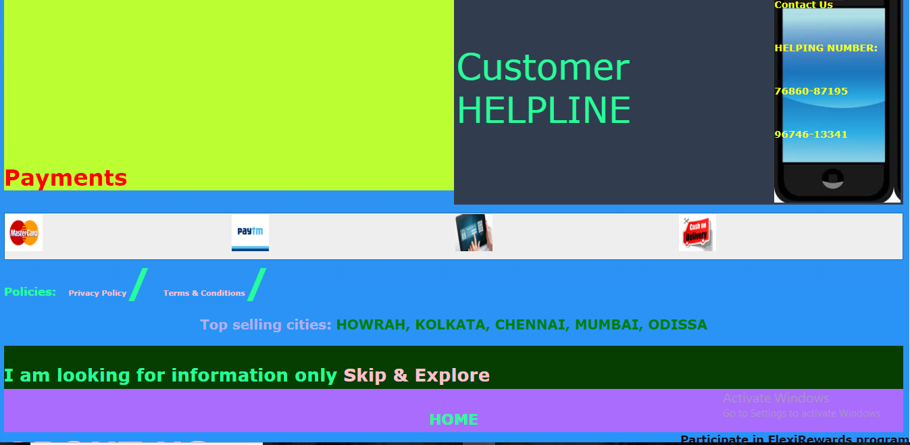

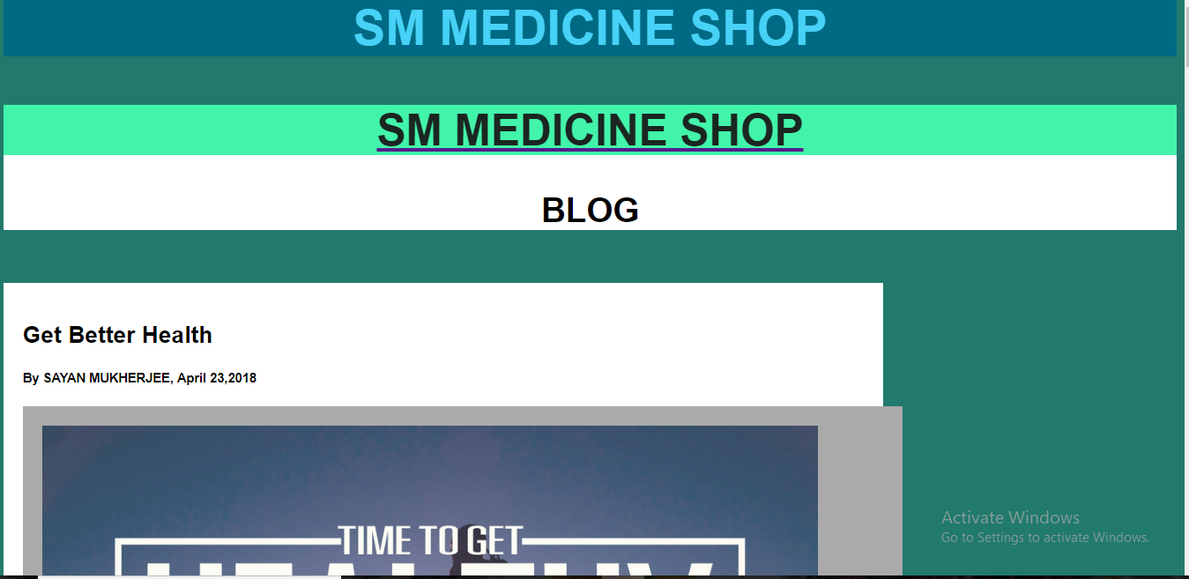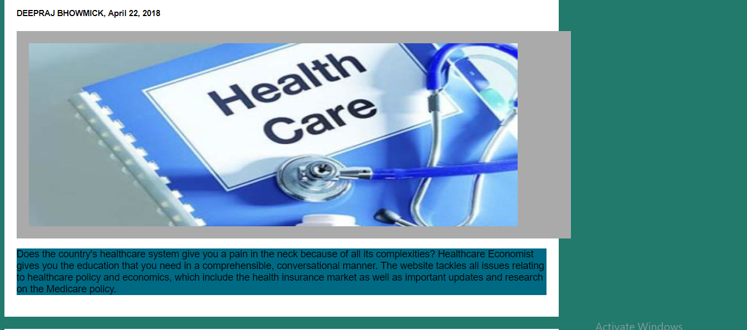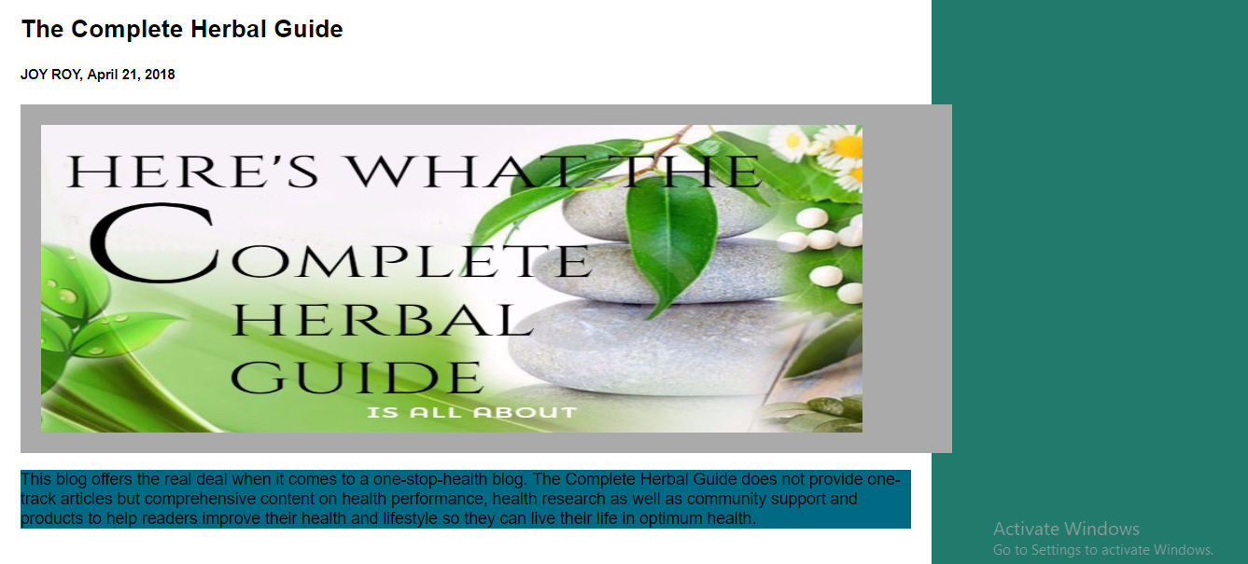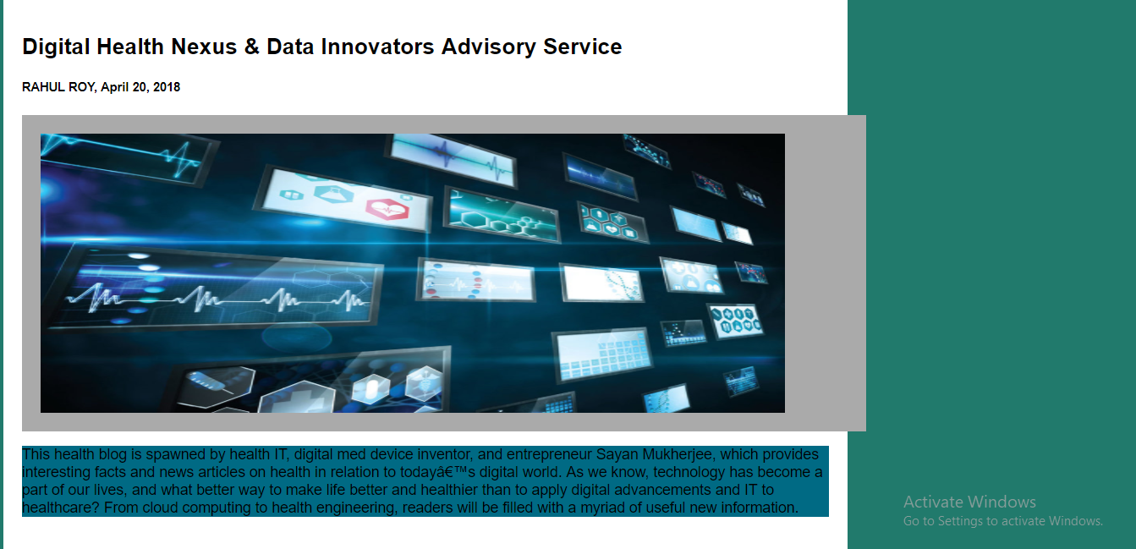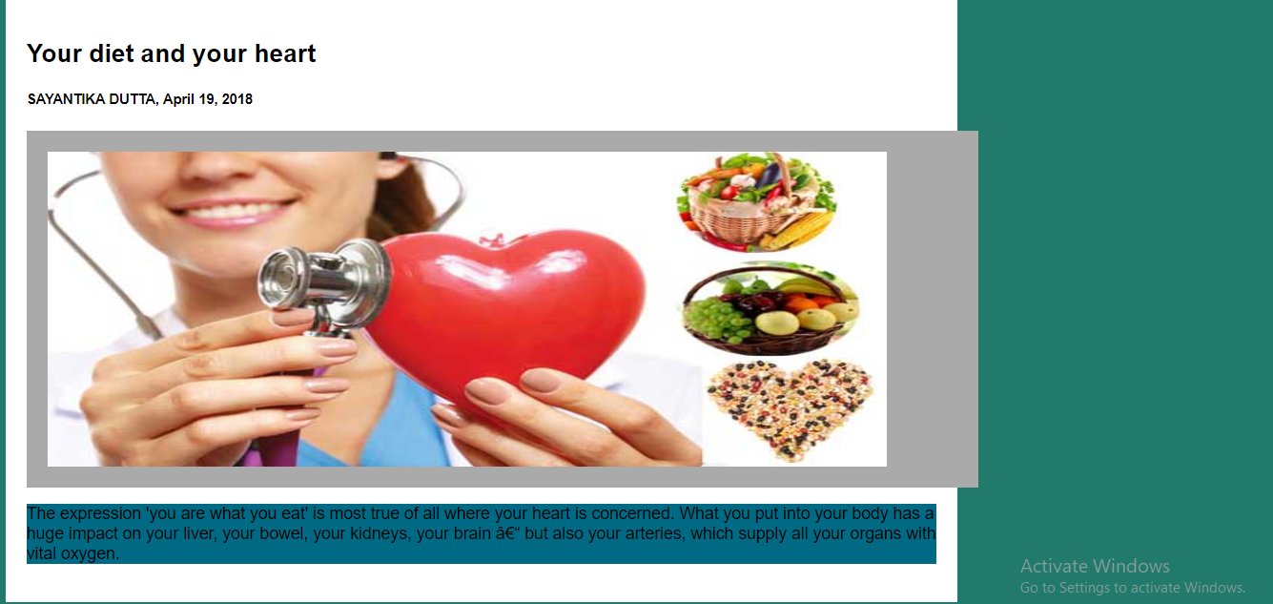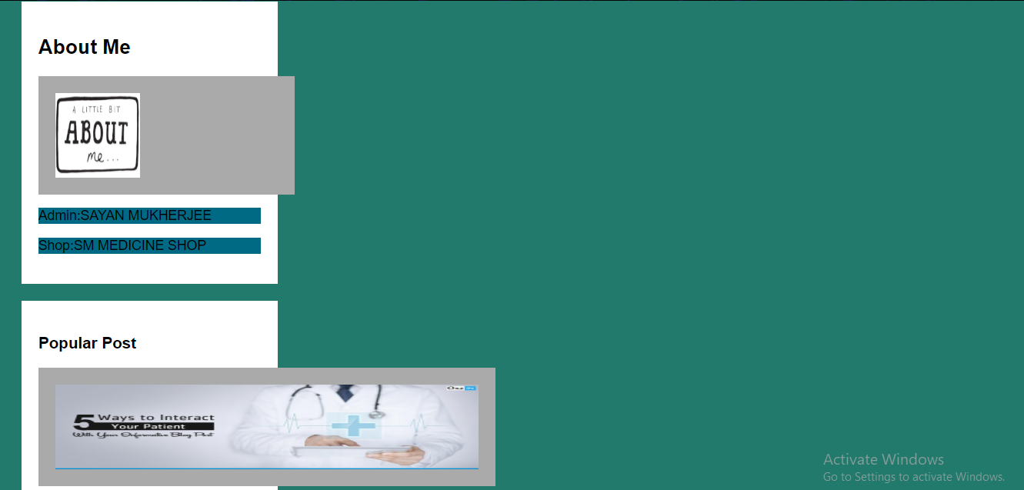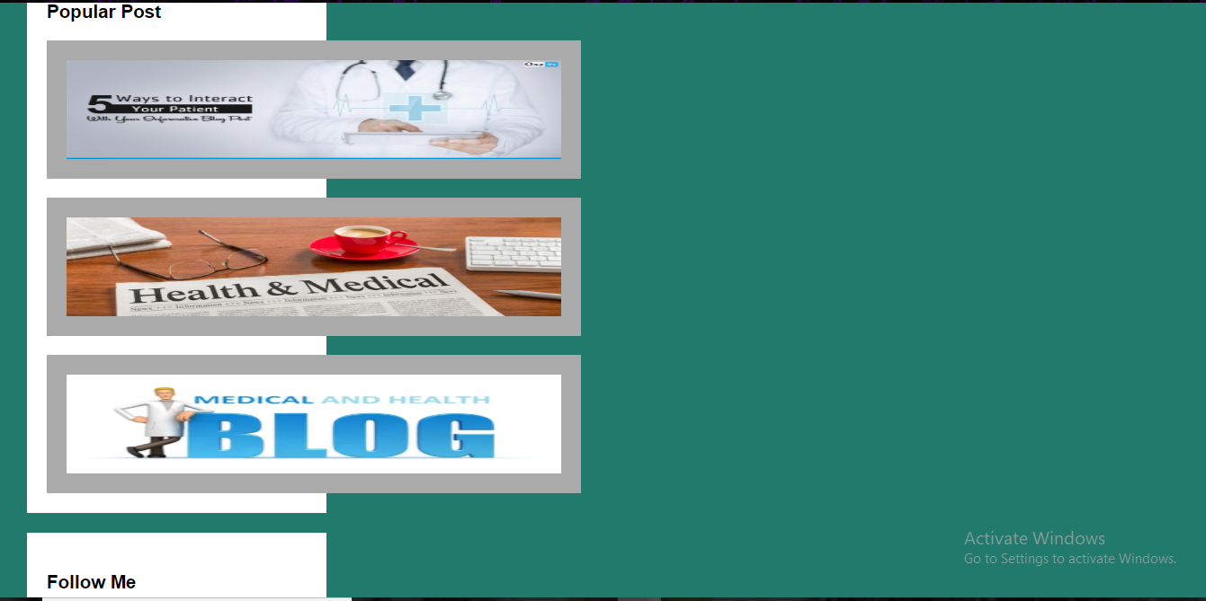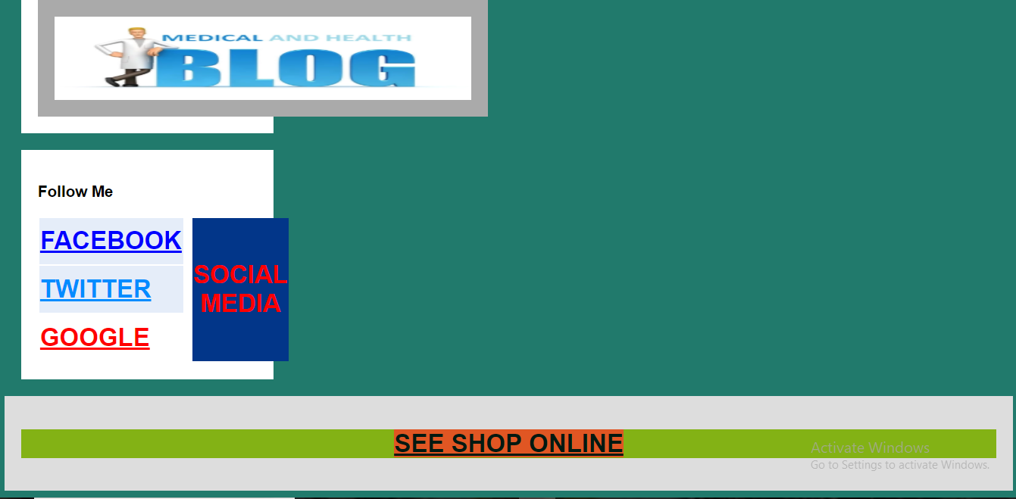

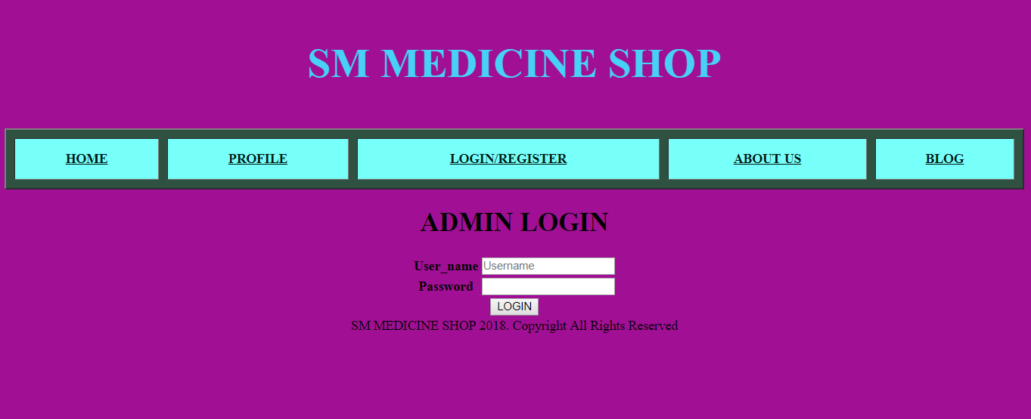

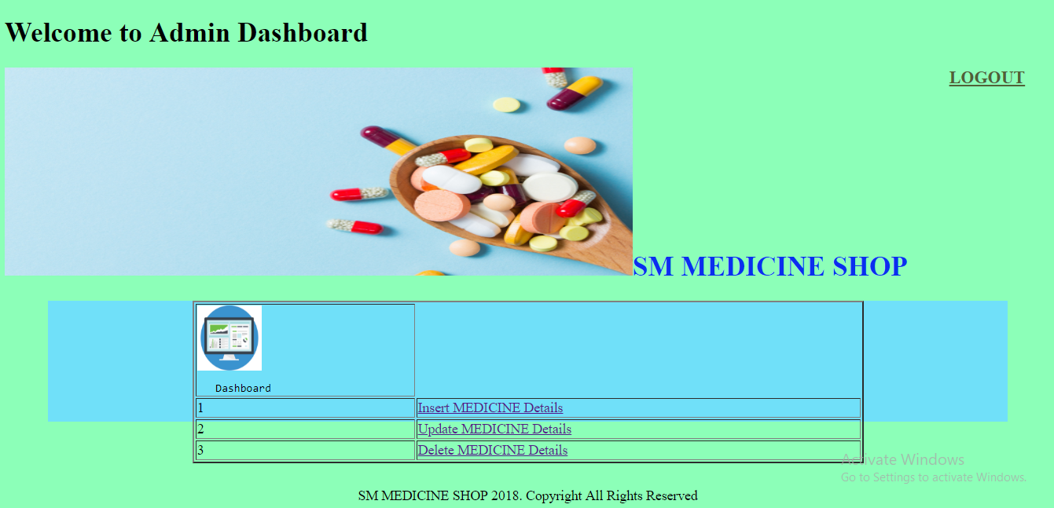

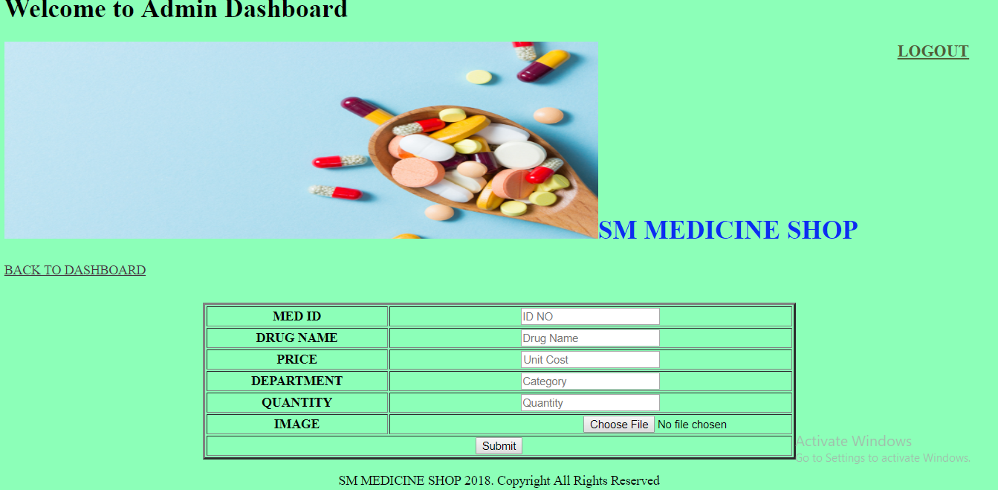

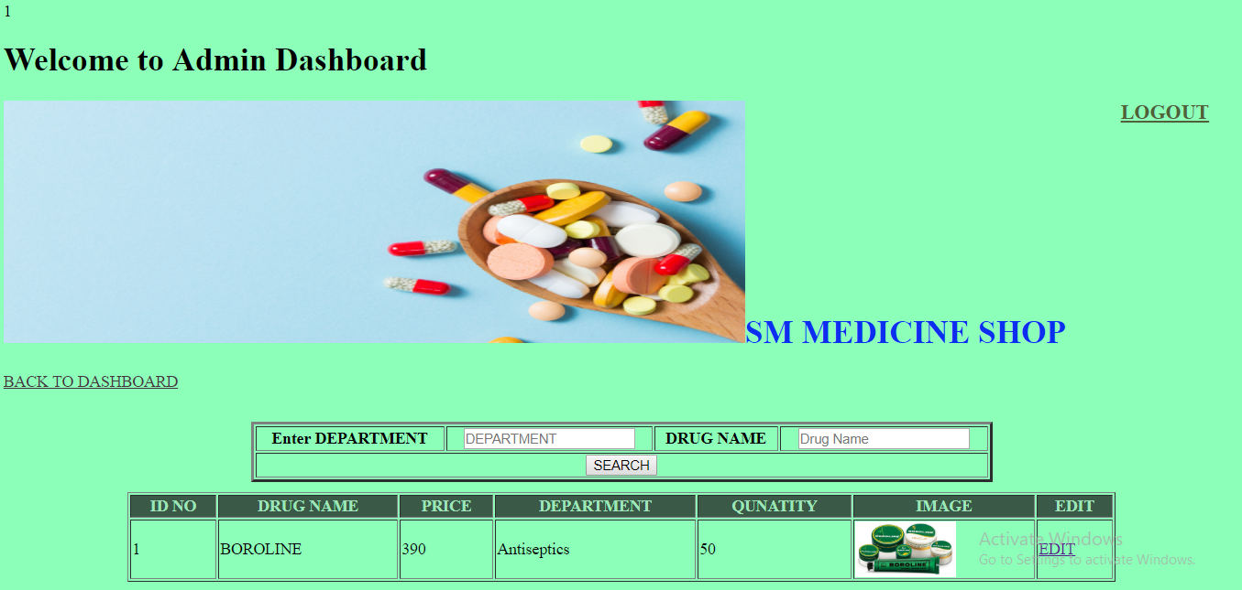

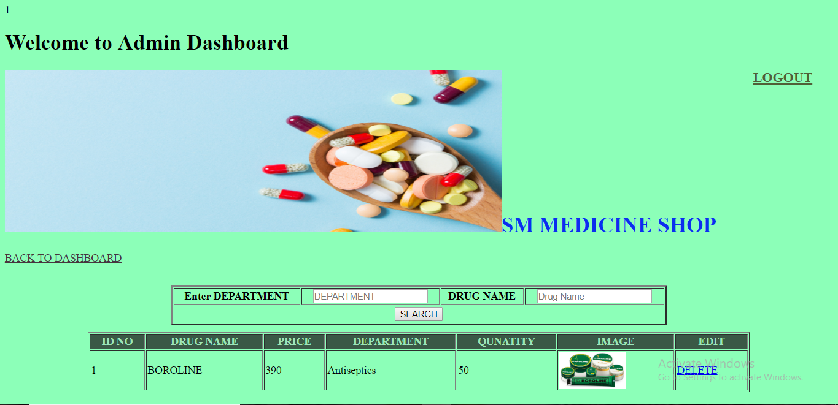

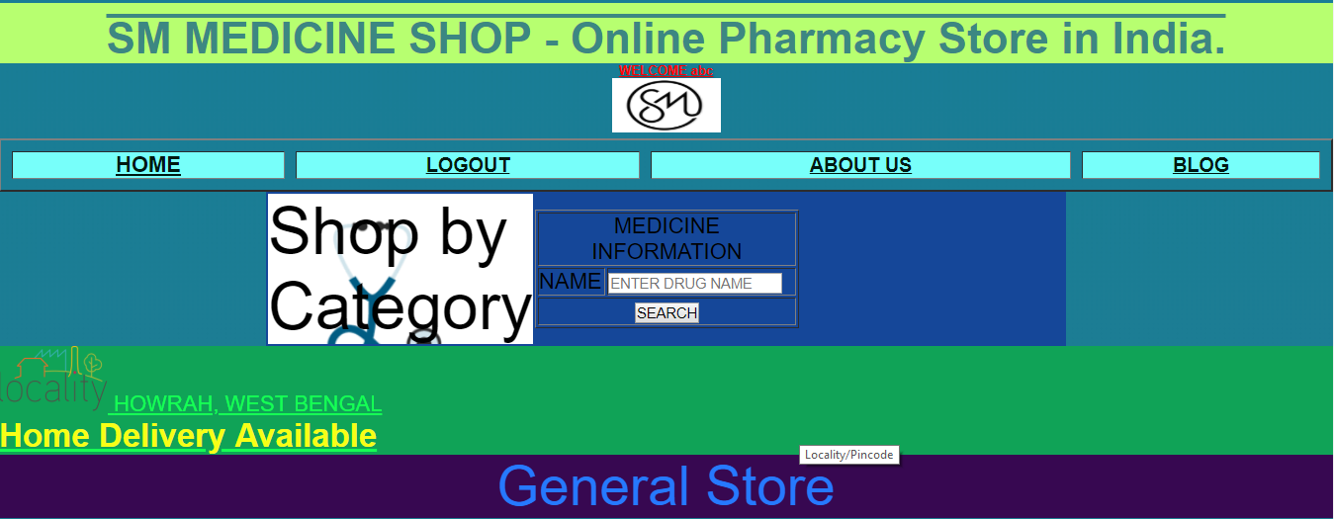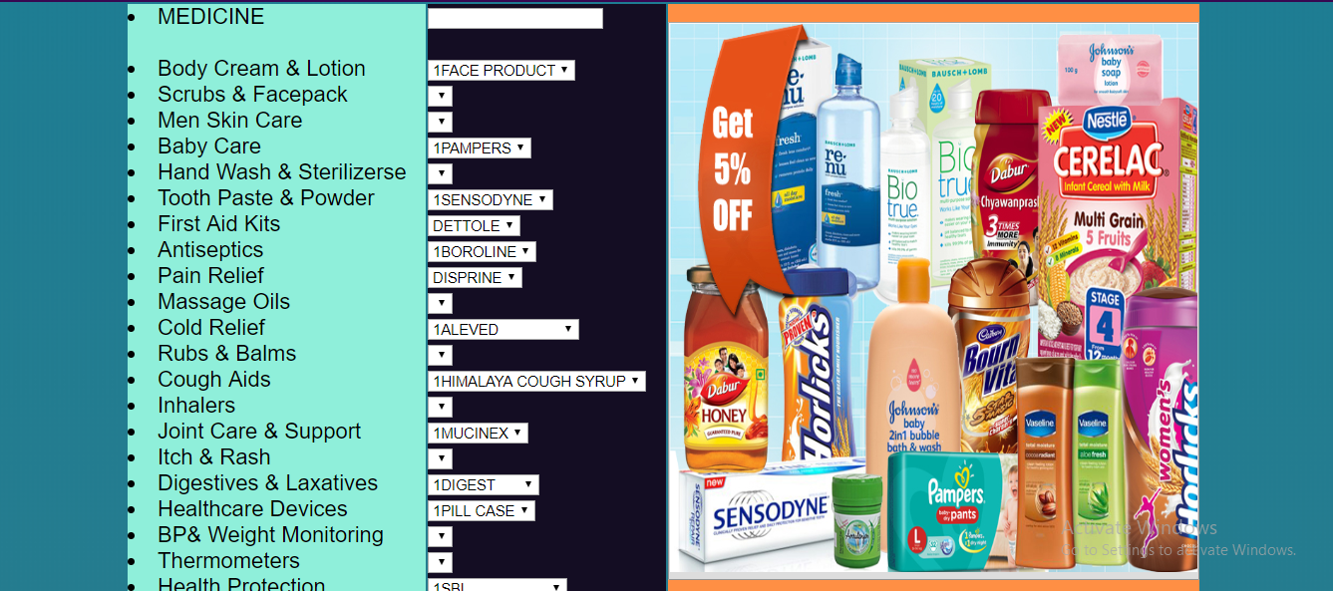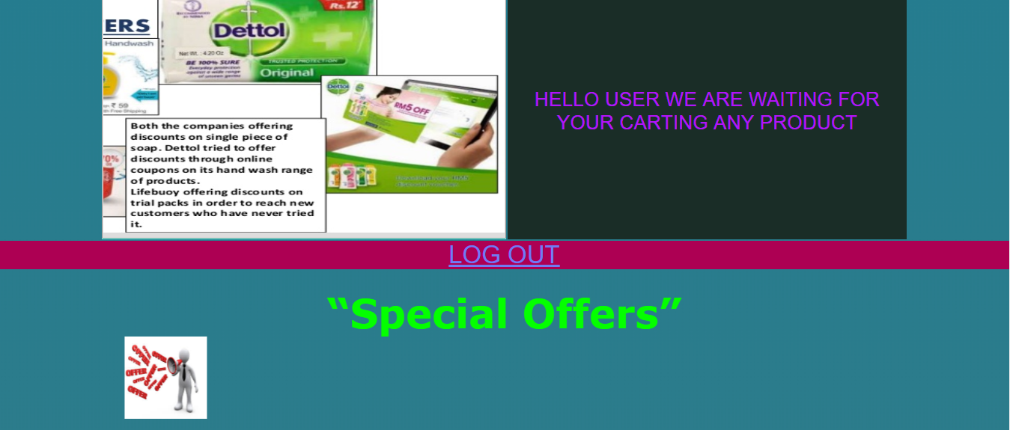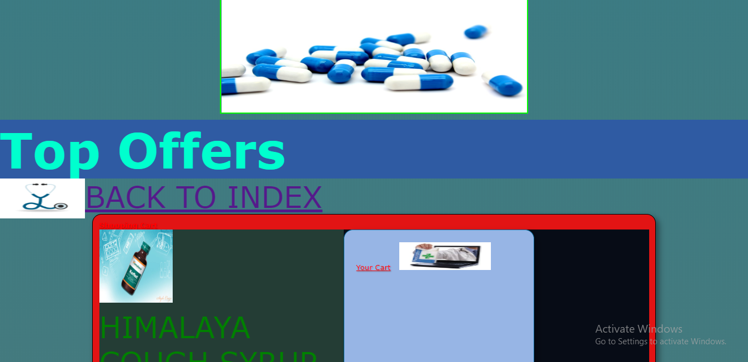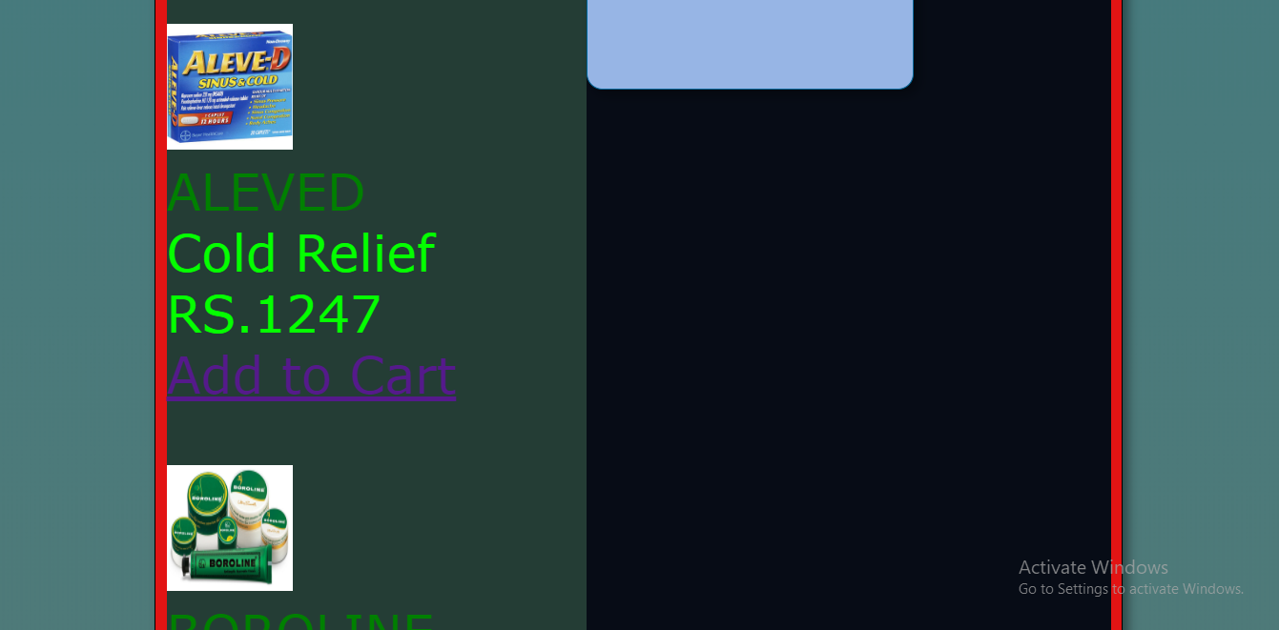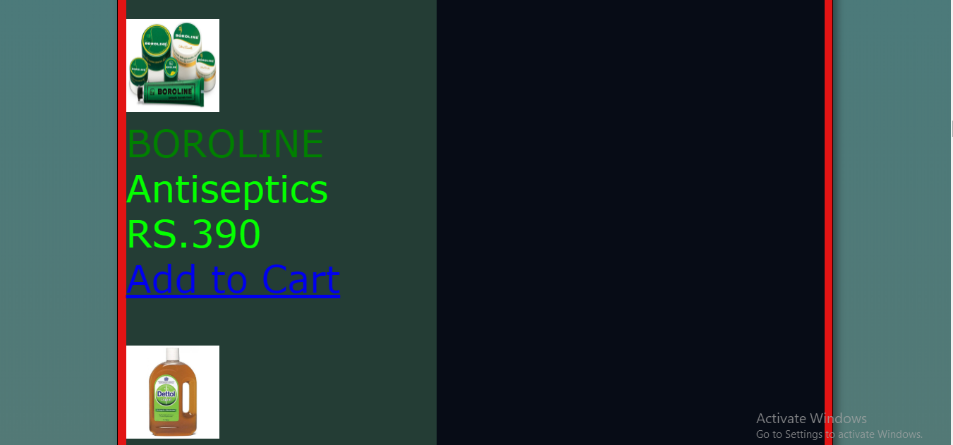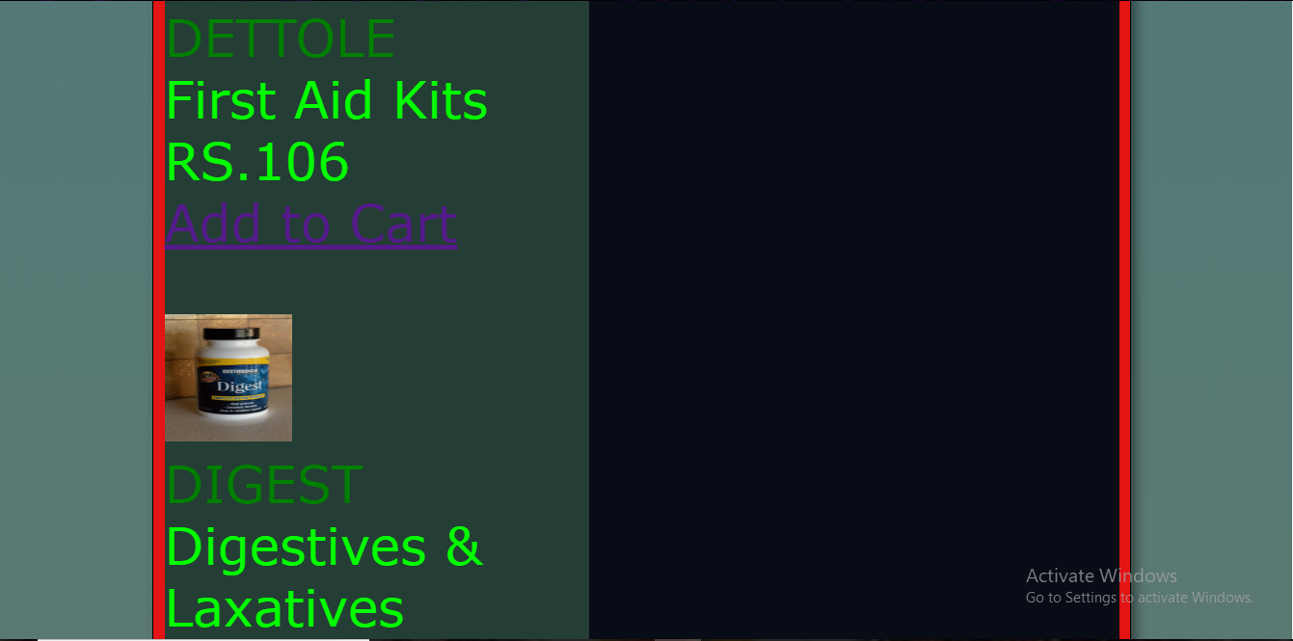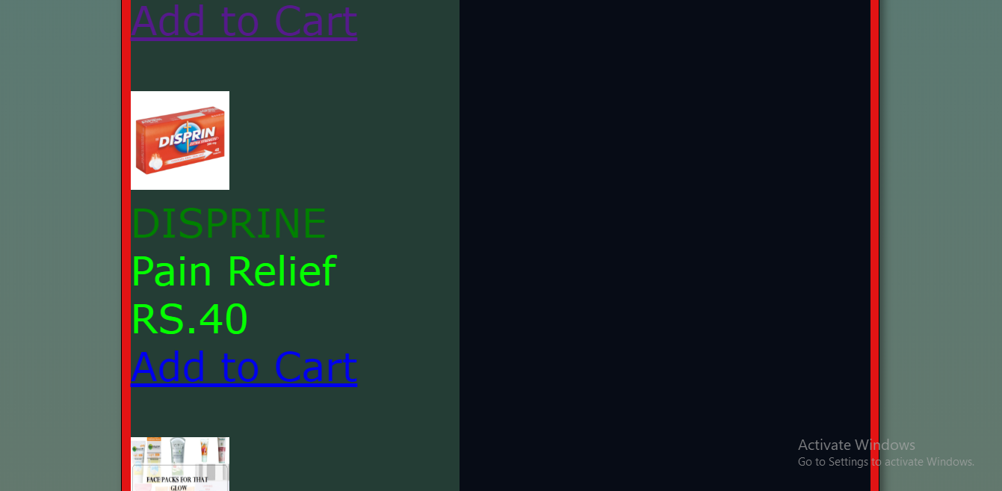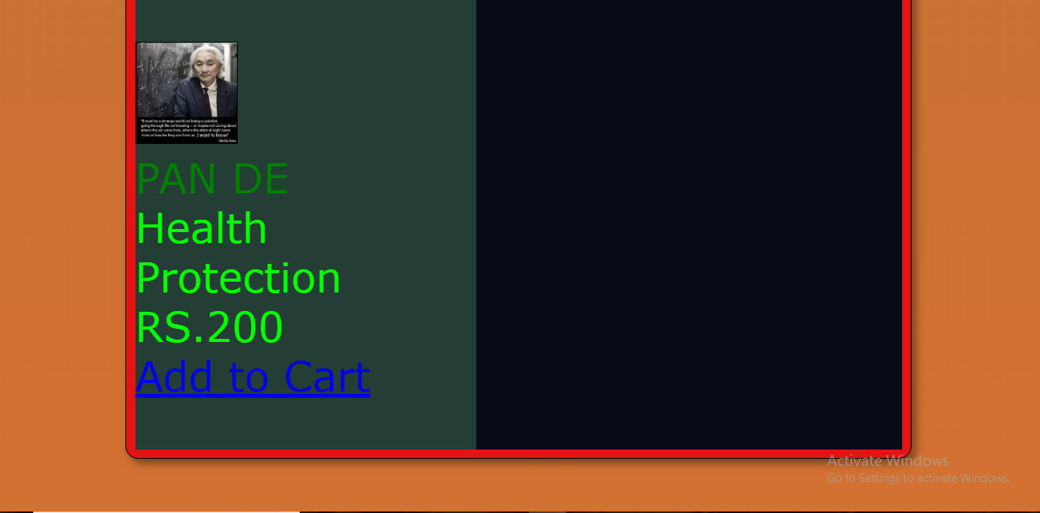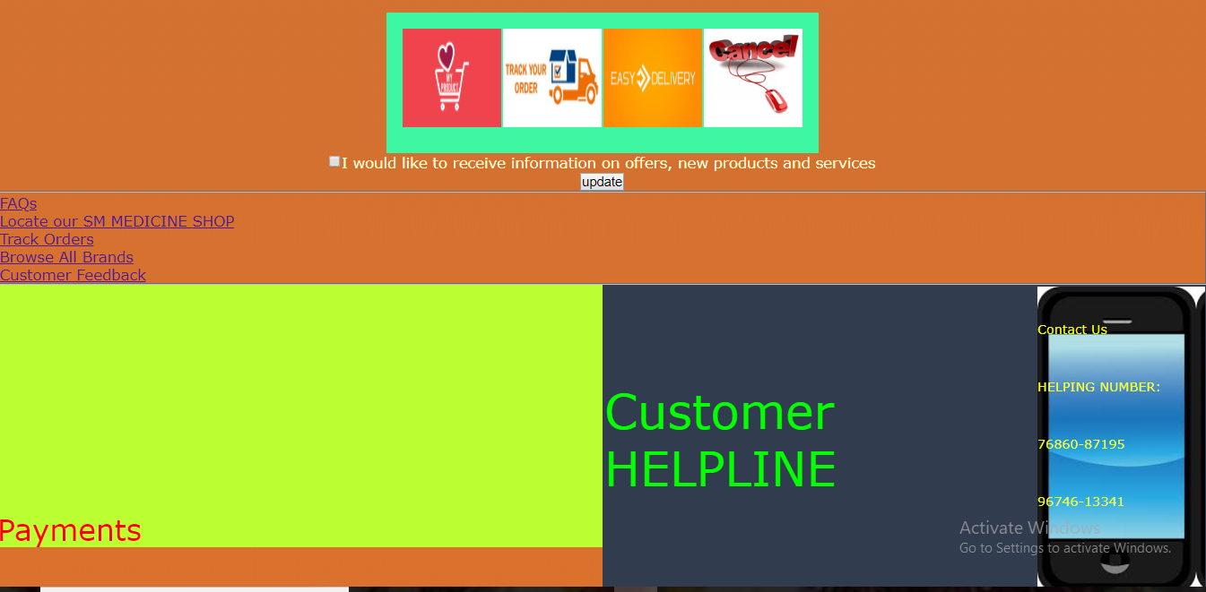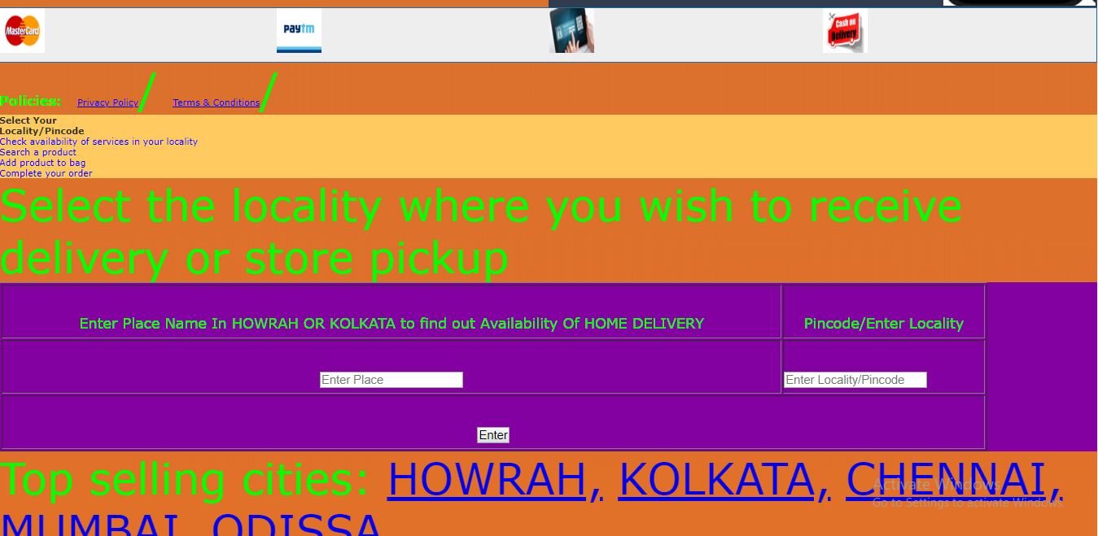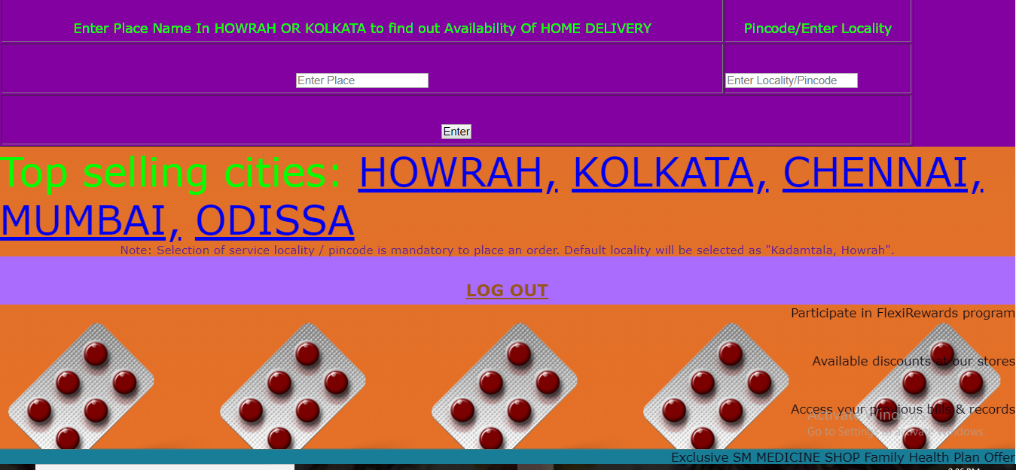

CODEING

SHOPPING:

<?php

session_start();

if($_SESSION['id'])

{

}

else

{

header('location:userlogin.php');

}

?>

<!doctype html>

<html lang="en">

<center>

<head>

<title>Online Pharmacy Store in India. Best value on medicines - SM MEDICINE SHOP</title>

<link rel="stylesheet" type="text/css" href="css/main.css">

<meta name="description" content="Handle your pharmacy, medicine store, departmental store and medicine shop data with the best pharmacy management system and web based solutionbuilt by Woksen." />

<meta http-equiv="X-UA-Compatible" content="chrome=1">

<style>

.mystyle {

width: 100%;

padding: 25px;

background-color: #ff8851;

color: blue;

font-size: 25px;

}

</style>

<h1 style="color:#3c8782;

background-color: #b7ff70;

text-decoration: overline;

margin-top:5px;

padding-top: 10px;

font-size: 40px;">SM MEDICINE SHOP - Online Pharmacy Store in India.</h1>

</head>

<body style="background: linear-gradient(#187d96, #e57027);">

<h3>WELCOME <?php echo $_SESSION['id']?></h3>

<header>

<table border="2" align="center" width="100%" cellspacing="10" cellpadding="15" background="medicine2.jpg"><tr bgcolor="#77fffa"><th><a style="color: #001911;" href="#top">HOME</a></th>

<th> <a style="color: #001911; font-size: 18px;" href="logout.php">LOGOUT </a></th>

<th> <a style="color: #001911; font-size: 18px;" href="aboutus1.php">ABOUT US </a></th>

<th> <a style="color: #001911; font-size: 18px;" href="blog1.html"> BLOG</a></th>

</tr>

<img src="/pms/images/download.png" height="50 px" width="100 px" title="SM MEDICINE" alt="SM MEDICINE">

<br/>

<table width="60%" bgcolor="#154799"><tr><td background="/pms/images/doctors.png" width="50px" >

<p color="#13b5a7" style="font-size: 3em;">Shop by Category</p>

</td>

<td>

<form method="POST" action="shop1.php">

<table style="width:50%" align="center" border="1">

<tr><td colspan="2" align="center">MEDICINE INFORMATION</td>

<tr><td align="left">NAME</td><td><input type="text" name="name" placeholder="ENTER DRUG NAME"></td></tr>

<tr><td colspan="2" align="center"><input type="submit" name="submit" value="SEARCH"></td></tr>

</table>

</form>

</td>

</tr></table>

<?php

if(isset($_POST['submit']))

{

$name = $_POST['name'];

include('dbcon.php');

include('function1.php');

showdetails($name);

}

?>

<div align="left" style="background-color:#10a357;">

<a style="color: #16ff54;" href="#locality" role="button" title="Locality/Pincode" data-toggle="modal" data-target="#LocalityModal" onclick="getLocality();">

<img src="/pms/images/locality.png" height="60" width="100">

HOWRAH, WEST BENGAL

<h2 style="color: #f7ff16;">Home Delivery Available</h2>

</a>

</div></center></header>

<body>

<div style="background-color: #370851;" align="center">

<font style="color: #2679ff ; font-size: 50px; ">General Store</font>

</div>

<div align="center">

<form name="myform" action="">

<table width="80%" align="center"><tr><td style="background-color: #8fefda;">

<li><label for="name">MEDICINE</label></li>

<br>

<li><label for="select_value" >Body Cream & Lotion</label></li>

<li><label for="select_value" >Scrubs & Facepack</label></li>

<li> <label for="select_value" >Men Skin Care</label></li>

<li><label for="select_value" >Baby Care</label></li>

<li><label for="select_value" >Hand Wash & Sterilizerse</label>

</li>

<li><label for="select_value" >Tooth Paste & Powder</label>

</li>

<li><label for="select_value" >First Aid Kits</label></li>

<li><label for="select_value" >Antiseptics</label></li>

<li><label for="select_value" >Pain Relief</label></li>

<li><label for="select_value">Massage Oils</label></li>

<li><label for="select_value">Cold Relief</label></li>

<li><label for="select_value">Rubs & Balms</label></li>

<li><label for="select_value">Cough Aids</label></li>

<li><label for="select_value">Inhalers</label></li>

<li><label for="select_value">Joint Care & Support

</label></li>

<li><label for="select_value">Itch & Rash</label></li>

<li><label for="select_value">Digestives & Laxatives</label></li>

<li><label for="select_value">Healthcare Devices</label></li>

<li><label for="select_value">BP& Weight Monitoring</label></li>

<li><label for="select_value">Thermometers</label></li>

<li><label for="select_value">Health Protection</label></li>

</td>

<td style="background-color: #140d23;">

<input type="text" name="name"></input><br><br>

<select name="select_value" onchange="myFunction4()">

<option value="1">1FACE PRODUCT</option></select><br>

<select name="select_value" onchange="myFunction4()">

<option value="1"></option>

</select>

<br/>

<select name="select_value" onchange="myFunction4()">

<option value="1"></option>

</select>

<br/>

<select name="select_value" onchange="myFunction4()">

<option value="1">1PAMPERS</option>

</select>

<br/>

<select name="select_value" onchange="myFunction4()">

<option value="1"></option>

</select>

<br/>

<select name="select_value" onchange="myFunction4()">

<option value="1">1SENSODYNE</option></select>

<br/>

<select name="select_value" onchange="myFunction4()">

<option value="1">DETTOLE</option>

<option value="1">SAVLON</option></select><br/>

<select name="select_value" onchange="myFunction4()">

<option value="1">1BOROLINE</option></select><br>

<select name="select_value" onchange="myFunction4()">

<option value="1">DISPRINE</option><br>

<option value="1">SARIDON</option></select><br/>

<select name="select_value" onchange="myFunction4()">

<option value="1"></option></select><br>

<select name="select_value" onchange="myFunction4()">

<option value="1">1ALEVED</option>

<option value="1">2VICKS VAPORUB</option></select><br>

<select name="select_value" onchange="myFunction4()">

<option value="1"></option></select><br>

<select name="select_value" onchange="myFunction4()">

<option value="1">1HIMALAYA COUGH SYRUP</option></select><br>

<select name="select_value" onchange="myFunction4()">

<option value="1"></option></select><br>

<select name="select_value" onchange="myFunction4()">

<option value="1">1MUCINEX</option></select></br>

<select name="select_value" onchange="myFunction4()">

<option value="1"></option></select></br>

<select name="select_value" onchange="myFunction4()">

<option value="1">1DIGEST</option>

<option value="2">2GELUSIL</option>

<option value="3">3POLYCROL</option>

<option value="4">4RANTAC</option>

</select><br>

<select name="select_value" onchange="myFunction4()">

<option value="1">1PILL CASE</option></select><br>

<select name="select_value" onchange="myFunction4()">

<option value="1"></option></select><br>

<select name="select_value" onchange="myFunction4()">

<option value="1"></option></select><br>

<select name="select_value" onchange="myFunction4()">

<option value="1">1SBL</option>

<option value="2">2REVITAL</option>

<option value="3">3SHAMPOO</option>

<option value="4">4CUREGARDON</option>

<option value="5">5PAN DE</option>

<option value="6">6VIAGRA</option>

<option value="7">7NEEM OIL</option>

<option value="7">8P-PRO-DS</option>

<option value="7">9REVITAL</option>

</select><br/>

</td>

<td bgcolor="#ff8f44" ><div id="myDIV1">

<button onclick="myFunction1()">

<marquee behavior="alternate" direction="alternate"><img src='/pms/images/offer.jpg' id='offer' alt="OTC & Health Needs" height="500" width="500" /></marquee></button>

<script>

function myFunction1() {

var element = document.getElementById("myDIV1");

element.classList.toggle("mystyle");

}</script>

</div>

</td></tr>

<tr><td colspan="2" style="background-color:#51ffed;"><div style="background-color: #51ffed;" id="myDIV2">

<button onclick="myFunction2()"><marquee behavior="alternate" direction="alternate"><img src="/pms/images/dettol.jpg" width="800" height="300" id='MART_10107Img' alt="Nutrition"/> </marquee></button> <script> function myFunction2() {

var x = document.getElementById("myDIV2");

if (x.innerHTML === "Please Search the product DETTOLE")

{

x.innerHTML = "Swapped text!";

} else {

x.innerHTML = "Please Search the product DETTOLE";

}

}

;</script></td><td align="center" bgcolor="#1a2d27"><font size="5px" style="color:#b413f9;">HELLO USER WE ARE WAITING FOR YOUR CARTING ANY PRODUCT</font></td></tr>

</table>

<script type="text/javascript">

function myFunction4() {

var x = parseInt(document.getElementsByName("select_value")[0].value);

alert((THIS PRODUCT HAS OFFER));

}

</script>

</form>

</div>

<div align="center" style="background-color:#ad0053;">

<a style="color: #6f7cf2; font-size: 30px; text-align: center; text-decoration-style: ;" href="logout.php">LOG OUT </a></div>

<br>

<center>

<font color="#04ff00" face="verdana" size="30px">

<b><q>Special Offers</q></b></fony>

<marquee behavior="scroll" direction="left"><img src="/pms/images/offer3.jpg" height="100" width="100" alt="Offers" title="Offers"></marquee>

</center>

</header>

<div style="background-color: #3f593a;" id="myDIV" align="center">

<button onclick="myFunction()"><marquee behavior="scroll" direction="up"><img src="/pms/images/diper.jpg" height="30%" width="100%" title="Babydiapers" alt="Babydiapers"></marquee></button>

<script> function myFunction() {

var x = document.getElementById("myDIV");

if (x.innerHTML === "Please Search PAMPERS") {

x.innerHTML = "Swapped text!";

} else {

x.innerHTML = "Please Search PAMPERS";

}

} </script>

</div>

</div>

<br>

<center>

<table style="

border-spacing: 5px 12px;

padding: 0 8px 8px 0;

border: 2px solid #c625ea;

background-color: #ea2567; text-align: center;" ><tr>

<td background="/pms/images/special.gif" style="background-size: 50% 50%;" >

<p><a href="#paytm" style="color: #1022e8; font-size: 30px;" onclick="">Upto 40% Off<small style="color: #1022e8;">Jumbo Offer on Using PAYTM</small></a></p>

</td>

<td style="background-size: contain;" bgcolor="#7eea25"><a href="" ><img src="/pms/images/banner2.png" title="banner" alt="" width="400px" height="300px"></a></td>

</tr>

<tr><td>

<img src="/pms/images/banner.png" title="SportsNutrition" alt="banner2" width="500px" height="400px" >

</td><td>

<a href="userlogin.php" onClick="alert('YOU MUST USE PAYTM 2nd TIME FOR PAYMENT TO CART ANY PRODUCT!')"><img src="/pms/images/paytm" height="400px" width="400px" title="Flexi Rewards" alt="Flexi Rewards"></a>

</td></tr>

</table>

</center>

<section>

<div style="background-color: #331821;">

<p style="color:#f4f7ef; text-decoration-line:3; text-align: left; font-size: 20px; ">Maximize your savings</p>

<p style="text-decoration-line:2; text-align: left; font-size: 10px;" >With FlexiRewards, you choose the reward - cash discount or free goods. Either way, we guarantee maximum value for your money.</p>

<p style="color:#f4f7ef; text-decoration-line:3; text-align: left; font-size: 20px; ">Click and pick</p>

<p style="text-decoration-line:2; text-align: left; font-size: 10px;" >Click to buy a range of products across categories - Pharmacy, Personal care, Nutrition, Baby care, Household etc., and pick them up at any of over 50 stores across the country</p>

<p style="color:#f4f7ef; text-decoration-line:3; text-align: left; font-size: 20px;">Home delivery</p>

<p style="text-decoration-line:2; text-align: left; font-size: 10px;">We offer convenient home delivery of medicines & general goods in several locations, with upload of a valid prescription for medicines.</p>

</div>

</section>

<div>

<center><img height="200" width="500" border="2" src="/pms/images/medine.jpg" title="" alt="" /></center>

</div>

</div>

<section >

<div style="background-color: #2f5ba3;">

<h2 style="color: #00ffce; text-decoration-line: 50; font-weight: bold; font-size: 80px; " >Top Offers<span>&nbsp;</span></h2>

</div>

<div>

<header><img id="logo" src="/pms/images/doctors.png" height="65px" width="140px">

</header>

<div>

<?php include("cart.php"); ?>

<div id="main_div"><h3>Shooping Cart</h3>

<div id="division" style="background-color: #070c16;">

<section id="main_section" style="background-color:#243d35;">

<?php display_cart(); ?>

</section>

<aside id="side"><span class="your_cart">Your Cart</span>&nbsp;&nbsp<img src="/pms/images/download1.jpg" height="45" width="150">

<br/><br/>

</aside>

</div>

</div></div></section>

<br/>

<section>

<div align="center">

<table bgcolor="#3df7a3" style="padding: 15px; text-align: center;">

<tr><th><img src="/pms/images/product.png" width="100" height="100" title="100% Genuine Products" alt="100% Genuine Products"></th>

<th><img src="/pms/images/track.jpg" width="100" height="100" title="Track Your Order" alt="Track Your Order">

</th>

<th><img src="/pms/images/easy.jpg" height="100" width="100" >

</th>

<th>

<img src="/pms/images/cancel.jpg" height="100" width="100">

</th></tr>

</table>

</div>

</section>

<section ><form><center>

<p style="color: #fafcd6; font-size:15px; "><input type="checkbox">I would like to receive information on offers,

new products and services<br><a style="color: #101f3a"><input type="button" name="update" value="update" onClick="alert('We SEND YOU CONFIRMATION TO YOUR MOBILE NO. AND EMAIL')"></a></p>

</center></form></section>

<div>

<fieldset><a style="margin: 0 auto;

font-size:15px;

clear: both;

display: block;

text-align: left;

" href="faqs1.php" title="FAQs">FAQs</a>

<a style=" margin: 0 auto;

font-size:15px;

clear: both;

display: block;

" href="" title="Locate a SM MEDICINE Store">Locate our <span>SM MEDICINE </span>SHOP</a>

<a style=" margin: 0 auto;

text-align: left;

font-size:15px;

clear: both;

display: block;

" href="" title="Track Orders">Track Orders</a>

<a style=" margin: 0 auto;

text-align: left ;

font-size:15px;

clear: both;

display: block;" href="#top" title="Browse All Brands">Browse All Brands</a>

<a style="margin: 0 auto;

text-align: left;

font-size:15px;

clear: both;

display: block;

" href="" title="Customer Feedback">Customer Feedback</a></fieldset></div>

<table bgcolor="#313d4f" align="right" width="50%"><tr><td>Customer HELPLINE </td><td><div style="background-image: url('/pms/images/phone.jpg'); width:170px; height:310px;"><font size="2px" style="color:#f6ff05;" align="center">Contact Us<br>HELPING NUMBER: 76860-87195

<br>

96746-13341</font>

</div></div></td></tr></table>

<div><a name="paytm"><p style="color: #ff0000; font-size: 30px; text-align: left; padding-top: 230px; background-color: #bbff32;">Payments</p></a>

<table style=" border: 1px solid #1C6EA4;

background-color: #EEEEEE;

width: 100%;

text-align: left;

border-collapse: collapse;"><tr><td>

<a onClick="alert('YOU NEED TO CREATE A BILL FIRST')"><img src="/pms/images/mc.png" height="50" width="50" alt="MasterCard" title="MasterCard"></a></td><td><a href="javascript:void();" onClick="alert('YOU NEED TO CREATE A BILL FIRST')">

<img src="/pms/images/paytm3.jpg" height="50" width="50" alt="Paytm" title="Paytm"></a>

</td><td><a href="javascript:void();" onClick="alert('YOU NEED TO CREATE A BILL FIRST')"><img src="/pms/images/nb.jpg" height="50" width="50" alt="Net Banking" title="Net Banking"></a> </td><td><a href="javascript:void();" onClick="alert('YOU NEED TO CREATE A BILL FIRST')"><img src="/pms/images/cod.jpg" alt="Cash On Delivery" height="50" width="50" title="Cash On Delivery"></a></td></tr></table></div>

<div >

<strong style="font-size: 15px; text-align: left;">Policies:</strong>

<span><a href="/privacypolicy" style="font-size:10px;">Privacy Policy</a>/</span>

<span><a href="/termsandconditions" style="font-size:10px;">Terms & Conditions</a>/</span>

</div>

<footer>

<div style="background-color: #ffca60;" ><h5 style="color: #2f331c; font-size: 10px;">Select Your<br><strong>Locality/Pincode</strong></h5>

<ul style="color: blue;">

<li style="font-size: 10px;">Check availability of services in your locality</li>

<li style="font-size: 10px;">Search a product</li>

<li style="font-size: 10px;">Add product to bag</li>

<li style="font-size: 10px;">Complete your order</li>

</ul>

</div>

<p>Select the locality where you wish to receive delivery or store pickup</p>

<span style="display:none;">

Home Delivery &amp; store pickup available

</span>

<div style="background-color: #8301a0;"><a name="locality"><form name="locality">

<table align="center" width="90%" border="1"><tr><td align="center"><font size="3px">Enter Place Name In HOWRAH OR KOLKATA to find out Availability Of HOME DELIVERY</font></td><td align="center"><font size="3px">Pincode/Enter Locality</font></td></tr><tr><td align="center">

<input tabindex="101" type="text" id="sltdCity" name="enteredCity" autocomplete="off" placeholder="Enter Place"></td><td><input tabindex="102" type="number" id="sltdLocality" autocomplete="off" name="enteredLoc" placeholder="Enter Locality/Pincode" value=""/></td></tr>

<tr><td colspan="2" align="center"><input type="submit" name="submit" value="Enter"></td></tr></table>

</form></a></div>

<div>

<p class="size-10 color-grey margin-t-5">Top selling cities:

<a onclick="selectCity('HOWRAH')" href="javascript:;">HOWRAH,</a>

<a onclick="selectCity('KOLKATA')" href="javascript:;">KOLKATA,</a>

<a onclick="selectCity('CHENNAI')" href="javascript:;">CHENNAI,</a>

<a onclick="selectCity('MUMBAI')" href="javascript:;">MUMBAI,</a>

<a onclick="selectCity('ODISSA')" href="javascript:;">ODISSA</a>

</p>

</div>

</div>

<div>

<p style="color: #611f93; text-align: center; font-size: 14px ;">Note: Selection of service locality / pincode is mandatory to place an order. Default locality will be selected as "Kadamtala, Howrah".</p>

</div>

<div style="background-color: #aa6cfc;" align="center"><a style=" color: #965718; font-size: 20px; text-decoration-color: #965718; text-decoration-style: none;" href="index.php" >

<strong>LOG OUT</strong></a></div>

<div style="background-image: url('/pms/images/item.png');">

<a style="color: #0d0814; position: absolute;

right: 0; font-size:15px;">Participate in FlexiRewards program</a><br>

<a style="color:#0d0814; position: absolute;

right: 0; font-size:15px;">Available discounts at our stores</a><br>

<a style="color:#0d0814; position: absolute; right: 0; font-size:15px;">Access your previous bills & records</a><br>

<a style="color: #0d0814; position: absolute; right: 0; font-size:15px;">Exclusive SM MEDICINE SHOP Family Health Plan Offer</a></div></footer>

</body>

</html>

INDEX

<!doctype html>

<html lang="en" class="">

<head>

<style type="text/css">

p {

color:#b0b0f4;

font-size:18px;

font-familty:Cooper;

font-style:normal;

font-weight:bold;

}

h5 {

color:red;

text-decoration:underline;

}

*{

color: #eeef97;

}

.b{

color:#ff005d;

}

.pk {

color:#02f6ff;

}

div.a {

background-image: url('/pms/images/social1.png'); height:120px; width:800px;

background-attachment: fixed;

}

div,ul,li{

font-weight:bold;

color:#10332c;

}

p {

background-color: #006a84;

}

.bluecolor { background: blue; }

@-webkit-keyframes flash {

0% { opacity: .3; }

100% { opacity: 1; }

}

@keyframes flash {

0% { opacity: .3; }

100% { opacity: 1; }

}

.flash:hover {

opacity: 1;

-webkit-animation: flash 1s;

animation: flash 1s;

}

@-webkit-keyframes flash {

0%, 50%, 100% { opacity: 1; }

25%, 75% { opacity: 0; }

}

@keyframes flash {

0%, 50%, 100% { opacity: 1; }

25%, 75% { opacity: 0; }

}

</style>

<meta charset="utf-8">

<link rel="shortcut icon" href="images/favicon.png">

<link ref="Stylesheet" type="text/css" href="/css/style.css">

<meta name="description" content="Handle your pharmacy, medicine store, departmental store and medicine shop data with the best pharmacy management system and web based solutionbuilt by Woksen." />

<meta http-equiv="X-UA-Compatible" content="chrome=1">

<title>SM ONLINE PHARMACY SHOP</title>

<center><p style="color:#47d1f7;font-size:50px;font-style:normal;font-weight:bold;margin-top:10px;">SM MEDICINE SHOP</p>

<div class="pk">

<table border="2" align="center" width="100%" cellspacing="10" cellpadding="15" background="medicine2.jpg"><tr bgcolor="#77fffa"><th><a style="color: #001911;" href="#top">HOME</a></th>

<th style=""><a style="color: #001911; font-size: 18px;" href="profile.php">PROFILE</a></th>

<th> <a style="color: #001911; font-size: 18px;" href="userlogin.php">LOGIN/REGISTER </a></th>

<th> <a style="color: #001911; font-size: 18px;" href="aboutus.php">ABOUT US </a></th>

<th> <a style="color: #001911; font-size: 18px;" href="blog.html"> BLOG</a></th>

</tr>

</table></div>

</center>

</head>

<body class="full-screen-preview" bgcolor="#24393f">

<div>

<table border="2" width="100%" height="300" cellspacing="10" cellpadding="15" ><tr><td align="center" bgcolor="#3dff6d" width="50%">

<a class="b" href="shop.php" style="font-size:50px; text-decoration-color: #405372; font-family:Arial Black;"><img src="/pms/images/back.jpg" width="50%" height="50%"><br/>MEDICINE SHOP</a>

</td>

<td align="center" style="background: linear-gradient(#f7620c, #2594fc);">

<img class="flash" src="/pms/images/header.gif"width="70%" height="70%">

</td>

</tr>

</table>

</div>

<br />

<div>

<table border="0" align="center" width="100%" cellspacing="10" cellpadding="8" background="medicine2.jpg">

<tr><td colspan="6" align="center" bgcolor="#192d2d"><font size="6px" style="color:#72e514;" >HERE ARE SOME PICTURE OF MEDICINE WHICH HAS TOP DISCOUNT</font></td></tr>

<tr><td><img class="flash" src="/pms/images/revital" height="200px" width="150px" border="2"></td>

<td><img class="flash" src="/pms/images/s2" alt="s2.jpg" height="200px" width="150px" border="2"></td>

<td><img class="flash" src="/pms/images/nuti" alt="nuti.jpg" height="200px" width="150px" border="2"></td>

<td><img class="flash" src="/pms/images/med2" alt="med2.jpg" height="200px" width="150px" border="2"></td>

<td><img class="flash" src="/pms/images/prods" alt="prods.jpg" height="200px" width="150px" border="2"></td>

<td><img class="flash" src="/pms/images/faces" alt="faces.jpg" height="200px" width="150px" border="2"></td>

</tr>

<tr><td><img class="flash" src="/pms/images/neemoil" alt="neemoil.jpg" height="200px" width="150px" border="2"></td>

<td><img class="flash" src="/pms/images/rantac_150" alt="rantac_150.jpg" height="200px" width="150px" border="2"></td>

<td><img class="flash" src="/pms/images/savon" alt="savon.jpg" height="200px" width="150px" border="2"></td>

<td><img class="flash" src="/pms/images/polycrol" alt="polycrol.jpg" height="200px" width="150px" border="2"></td>

<td><img class="flash" src="/pms/images/digest" alt="digest.jpg" height="200px" width="150px" border="2"></td>

<td><img class="flash" src="/pms/images/dabur" alt="dabur.jpg" height="200px" width="150px" border="2"></td>

</tr>

</table>

</div>

<section>

<div>

<h1 align="center" style="color:#e9ff00;" >YOU MUST LOGED IN BEFORE CART ANY PRODUCT

</h3></div><br/>

<div style="background-color:#013b42;" >

<h3>SM MEDICINE SHOP is a pharmacy software which is responsive Modern design for any kind of pharmacy.

</h3>

<div>

<p> You must create account In our Web-Store to buy any product. SM MEDICINE SHOP allows your pharmacy to process, track, and dispense all prescriptions with the highest level of security, accuracy, and efficiency. This is the most powerful and efficient system on the market for any size pharmacy operation. The system will meet the end-to-end operational requirements to provide comprehensive pharmacy services.

</p>

</div>

</div>

</section>

<section style="background:#f7f7f7;">

<div style="background-color: #009351;">

<h2 style="color:orange;">MAIN FEATURES</h2>

</div>

<div>

<ul>

<li>Customer Management Module</li>

<li>Due Payment Management</li>

<li>Medicine, Drugs, Customers, Employees, Clients, supplier and Users management</li>

<li>Search Medicine, Customer, Purchase, Invoices by Its First Letter</li>

<li>Print Invoices</li>

<li>Alert Stock Management</li>

<li>Daily Sales Report</li>

<li>Latest Sales, Expense and Medicine</li>

<li>Sales Graph</li>

</ul>

</div>

</div>

</section>

<section>

<div style="background-color:#070819;">

<h3 class="m-b-0">“SM MEDICINE SHOP with everything you need

Increase sales, cut costs, and save time. All the features a retailer needs in one tool.

”</h3>

</div></section>

<section>

<div align="center" style="background-color:#28281d;">

<a style="color: #ffff00; font-size: 40px; text-align: center; text-decoration-style: ;" href="userlogin.php">LOGIN/REGISTER </a>

</div>

</section>

<div style="background-image: url('/pms/images/online1.jpg'); background-repeat: no-repeat" align="right">

<h3 style="text-align: left; color: #343a34;">Rich Knowledge</h3>

<span>SM MEDICINE SHOP is known for its ease of use with rich user Interface.</span>

<h3 style="text-align: left; color: #343a34;">Control and fast</h3>

<span>To have effective control over their businesses.</span>

<h3 style="text-align: left; color: #343a34;">More time for meaningful work</h3>

<span>

SM MEDICINE SHOP is known for its ease of use with rich user Interface.

</span>

</div>

<footer class="background-dark text-grey" id="footer">

<div class="footer-content">

<div class="container">

<div class="row">

<div class="col-md-12">

<div class="footer-logo float-left">

</div>

<p style="margin-top: 23px; background-color:black; ">SM MEDICINE SHOP combines global reach with local expertise. SM MEDICINE SHOP helps healthcare, transportation, mobile Internet, etc., in many of which, SM MEDICINE SHOP has a leading market share.

</p>

<div style="background-color:#7214e5;">

<h4 style="color: #ff3200;"></i> &nbsp; REFERENCE</h4>

<ul>

<li><a href="#" style="color: #ffa089;">Associates</a></li>

<li><a href="#" style="color: #ffa089;">Company Profile</a></li>

<li><a href="#" style="color: #ffa089;">Terms & Conditions</a></li>

<li><a href="#" style="color: #ffa089;">Privacy</a></li>

</ul>

</div>

<fieldset>

<div class="flash" style="background-image: url('/pms/images/ill'); background-position: 50% 55px; background-repeat: no-repeat">

<h4>&nbsp;CONTACT US</font></h4>

<ul style="padding-left:22px;">

<li style="margin-top:20px; color:#e80055;">

<strong>HOWRAH:</strong> 58/1/1 KADAMTALA , N.S DUUTA ROAD</li>

<li style="margin-top:20px; color:#e80055;">

<strong>KOLKATA:</strong> NP-9, Vasundhara Complex, Sector5, SaltLake, Kolkata, West Bengal 700102</li>

<li style="margin-top:20px; color:#02f6ff;"> <strong>Phone:</strong> +91 9674613341 </li>

<li style="margin-top:20px; color:#02f6ff;"> <strong>Mobile:</strong> +91 7686087195 </li>

<li style="margin-top:20px; color:#02f6ff;"> <strong>Email:</strong> <a href=""><span class="__cf_email__" data-cfemail="741d1a121b34031b1f07111a5a171b19">[email&#160;protected]</span></a></font></a>

</li>

<li style="margin-top:20px; color:#02f6ff ">Monday - Saturday: <strong>09:00 - 5:00</strong>

<br>Sunday: <strong>Closed</strong>

</li>

</ul>

<p style="color: white;">&copy; 2018 SM MEDICINE SHOP. All Rights Reserved.

</div>

</fieldset>

</footer>

<center>

<div class="a">

<table width="80%" height="30%"><tr><td bgcolor="#e5edf9">

<a href="" style="color: blue; font-size: 30px; font-family: Arial; font-weight: bold;">FACEBOOK</a></td>

<td></td> <td></td><td bgcolor="#023689" align="center" rowspan="3" style="color: #ff0000; font-weight: bold; font-size: 30px">SOCIAL MEDIA</td></tr>

<tr><td bgcolor="#e5edf9"><a href="" style="color: #028cff; font-size: 30px;font-family: Arial;font-weight: bold;">TWITTER</i></a></td></tr>

<tr>

<td bgcolor="white"><a href="" style="color: red; font-size: 30px;font-family: Arial;font-weight: bold;">GOOGLE</i></a></td></tr>

</table>

</div>

</center>

</body>

</html>

USER LOGIN:

<?php

session_start();

require 'dbconfig.php';

?>

<html lang="en">

<head>

<meta name="OPM" content="Accounting">

<meta name="description" content="Medical Store">

<meta name="Admin" content="Sayan">

<meta name="keyword" content=", Hospital, Clinic, Management, Software, Php, CodeIgniter, pharmacy, Accounting">

<link rel="shortcut icon" href="">

<link rel="stylesheet" href="css/style2.css">

<title>Login - Pharmacy Management System</title>

<style>

p {

background-color: #006a84;

}

.pk {

color:#02f6ff;

font-size: 15px;

}

.b{

background-image: url(/pms/images/pharma.png);

width: 50em;

height: 25em;

background-color: #295599;

}

div, p {

margin: 0;

padding: 0;

border: 0;

outline: 0;

font-size: 100%;

vertical-align: baseline;

}

</style>

<center><p style="color:#47d1f7;font-size:50px;font-style:normal;font-weight:bold;">SM MEDICINE SHOP</p>

<div class="pk">

<h3 align="right" style="margin-right:20px;"><a href="login.php" style="color:#f4ce42;">ADMIN LOGIN</a></h3>

<table border="2" align="center" width="100%" cellspacing="10" cellpadding="15" style="border-color:#24393f;"><tr bgcolor="#77fffa" style="border-color: #24393f;"><th style="border-color: #24393f;"><a style="color: #001911;" href="index.php">HOME</a></th>

<th><a style="color: #001911; font-size: 18px;" href="profile.php" style="border-color: #24393f;">PROFILE</a></th>

<th> <a style="color: #001911; font-size: 18px;" href="userlogin.php" style="border-color: #24393f;">LOGIN/REGISTER </a></th>

<th> <a style="color: #001911; font-size: 18px;" href="aboutus.php" style="border-color: #24393f;">ABOUT US </a></th>

<th> <a style="color: #001911; font-size: 18px;" href="#" style="border-color: #24393f;"> BLOG</a></th>

</tr>

</table></div></head>

<body style="background: linear-gradient(#1d0060,#970afc);">

<div class="b">

<form method="POST" action="log.php" >

<h5><b>SM ONLINE PHARMACY SHOP</b></h5>

<p><font size="10"><b>Log In Please</b></font></p>

<br/>

<table border="2" width="50%" cellspacing="5" cellpadding="5" background="medicine2.jpg">

<tr><th bgcolor="#478c5a">Enter Your Email</th><td>

<input type="email" class="form-control" name="email" placeholder="User Email" autofocus>

</td>

<tr><th bgcolor="#478c5a">Password</th><td>

<input type="password" class="form-control" name="password" value="" placeholder="Password"></td></tr>

<tr><td align="center">

<input type="reset" value="Reset"/></td>

</tr>

<tr><td align="">

<font color="#0e2851" size="20 px"><b>OR</b></font></td><th bgcolor="#478c5a">

<input type="submit" name="login" value="LOG IN"></th></tr>

<tr><td>

<a href="userregister.php">

<img src="/pms/images/reg.png" style="width:200px;height:42px;border:0;" align="right">

</a>

</td></tr>

<tr><td colspan="2" align="center"><?php if(isset($_REQUEST["err"]))

echo "Invalid User";

?></td></tr>

</table></form>

</center>

</div>

<div style="background-color: #295599; text-align: right;">

<form method="post" action="auth/forgot_password" class="demo">

<h4>Forgot Password?</h4>

<pre><font color="white">Insert Your Email to reset your password</font></pre>

<input type="text" name="email" placeholder="Email" autocomplete="off" class="form-control placeholder-no-fix">

<button data-dismiss="modal" class="btn btn-default" type="button">Cancel</button>

<input class="btn btn-success" type="submit" name="submit" value="submit">

</form>

</body>

</html>

USER REGIOSTER:

<?php

$conn=mysqli_connect("localhost","root","","pms");

?>

<html>

<head>

<meta http-equiv="Content-Type" content="text/html; charset=iso-8859-1" />

<title>Registration Form</title>

<link rel="stylesheet" href="css/style3.css">

<style>p {

background-color: #006a84;

}

p {

margin: 0;

padding: 0;

border: 0;

outline: 0;

font-size: 100%;

vertical-align: baseline;

}

.pk {

color:#02f6ff;

font-size: 15px;

}

</style>

<center><p style="color:#47d1f7;font-size:50px;font-style:normal;font-weight:bold;">SM MEDICINE SHOP</p>

</head>

<body>

<?php

if(isset($_POST['submit'])){

$name=$_POST['name'];

$lname=$_POST['lname'];

$email=$_POST['email'];

$password=$_POST['password'];

$address=$_POST['address'];

$mobile=$_POST['mobile'];

$gender=$_POST['gender'];

$dob=$_POST['dob'];

$sql_u="SELECT * FROM `userinfo` WHERE `email`='$email'";

$res_u = mysqli_query($conn, $sql_u) or die(mysqli_error($conn));

if (mysqli_num_rows($res_u) > 0)

{

$email_error = "email already exist";

echo "email already exist";

}

else{

$query="insert into userinfo(name,lname,email,password,address,mobile,gender,dob)values('$name','$lname','$email','$password','$address','$mobile','$gender','$dob')";

$run=mysqli_query($conn,$query);

if($run){

echo '<script type="text/javascript">alert("Successfully Registered")</script>';

header("location:userlogin.php");

}

else{

echo"error!".mysqli_error($conn);

}

}

}

?>

<center>

<div>

<form enctype="multipart/form-data" action="" method="POST">

<table width="50%" border="1" table style="background-color:#e4ef99">

<tr>

<td colspan="2" bgcolor="#4370b7"><h4><q><b><font size="20">Register Here</font></b></q></h4></td>

</tr>

<tr>

<td width="159" bgcolor="#0e912d"><font size="3"><b> Enter your Name</b></font></td>

<td width="218">

<input type="text" placeholder="your first name" name="name" pattern="[a-z A-Z]*" required />

<input type="text" placeholder="your last name" name="lname" pattern="[a-z A-Z]*" required /></td>

</tr>

<tr>

<td bgcolor="#0e912d"><font size="3"><b> Enter your Email</b></font></td>

<td><input type="email" name="email" required></td>

</tr>

<tr>

<td bgcolor="#0e912d"><font size="3"><b> Enter your Password</b></font></td>

<td><input type="password" name="password" required /></td>

</tr>

<tr>

<td bgcolor="#0e912d"><font size="3"><b> Enter your Address</b></font></td>

<td><textarea name="address" required></textarea></td>

</tr>

<tr>

<td bgcolor="#0e912d"><font size="3"><b> Enter your Mobile No</b></font></td>

<td><input type="text" pattern="[0-9]*" name="mobile" required /></td>

</tr>

<tr>

<td height="23" bgcolor="#0e912d"><font size="3"><b> Select your Gender</b></font></td>

<td>

Male<input type="radio" name="gender" value="m" required />

Female<input type="radio" name="gender" value="f" required />

</td>

</tr>

<tr>

<td bgcolor="#0e912d"><font size="3" required ><b> Select your DOB</b></font></td>

<td>

<input type="date" name="dob" max="2004-12-31" min="1940-01-02"><br>

</td>

</tr>

<tr>

<td colspan="2" align="center" bgcolor="#132bdd">

<input type="submit" name="submit" value="Register Me"/>

<input type="reset" value="Reset"/>

</td>

</tr>

</table>

</form>

<?php

?>

</div>

<div class="pk">

<table border="2" align="center" width="100%" cellspacing="10" cellpadding="15" style="border-color:#24393f;"><tr bgcolor="#77fffa" style="border-color: #24393f;"><th style="border-color: #24393f;"><a style="color: #001911;" href="index.php">HOME</a></th>

<th> <a style="color: #001911; font-size: 18px;" href="userlogin.php" style="border-color: #24393f;">LOGIN/REGISTER </a></th>

<th> <a style="color: #001911; font-size: 18px;" href="shop.php" style="border-color: #24393f;"> SEE SHOP ONLINE</a></th>

</tr>

</table></div>

</div>

</center>

</body>

</html>

Log.php:

<?php

session_start();

include 'dbconfig.php';

$email=$_POST['email'];

$password=$_POST['password'];

$sql="SELECT * FROM userinfo WHERE email='$email' AND password='$password' ";

$result = mysqli_query($conn,$sql);

$count = mysqli_num_rows($result);

if (!$row = $result->fetch_assoc())

{

header("Location:userlogin.php?err=1");

echo "you have enterd an incorrect password";

exit();

}

else

{

$_SESSION['id'] = $row['name'];

header("Location: shop1.php");

}

?>

REGISTER:

<?php

include 'dbconfig.php';

$name=$_POST['name'];

$email=$_POST['email'];

$password=$_POST['password'];

$sql="INSERT INTO userinfo (name, email, password) VALUES ('$name', '$email', '$password')";

$result = $conn->query($sql);

header("Location: shop1.php");

?>

T&C:

<html>

<head><h1 style="color:#3c8782;

background-color: #b7ff70;

text-decoration: overline;

margin-top:5px;

padding-top: 10px;

font-size: 40px;" align="center">SM MEDICINE SHOP - Online Pharmacy Store in India.</h1>

<div align="center" style="background-color: #184c56;">

<a href="index.php" ><img src="/pms/images/download.png" height="50 px" width="100 px" title="SM MEDICINE" alt="SM MEDICINE" ></a></div>

</head>

<body bgcolor="#9da6ea">

<h2 style="background-color: #16e2cb">TERMS & CONDITION</h2>

<p style="background-color: #e5196e;">

Conditions of Use

Welcome to our web site. The Virginia Academy of Fencing and its associates provide our services to you subject to the following conditions. If you visit or shop within this website, you accept these conditions. Please read them carefully.

PRIVACY

Please review our Privacy Notice, which also governs your visit to our website, to understand our practices.

ELECTRONIC COMMUNICATIONS

When you visit The Virginia Academy of Fencing or send e-mails to us, you are communicating with us electronically. You consent to receive communications from us electronically. We will communicate with you by e-mail or by posting notices on this site. You agree that all agreements, notices, disclosures and other communications that we provide to you electronically satisfy any legal requirement that such communications be in writing.

<p style="background-color: #5afc32;">

COPYRIGHT

All content included on this site, such as text, graphics, logos, button icons, images, audio clips, digital downloads, data compilations, and software, is the property of The Virginia Academy of Fencing or its content suppliers and protected by international copyright laws. The compilation of all content on this site is the exclusive property of The Virginia Academy of Fencing, with copyright authorship for this collection by The Virginia Academy of Fencing, and protected by international copyright laws.

<p style="background-color: #3980cc;">

TRADE MARKS

The Virginia Academy of Fencings trademarks and trade dress may not be used in connection with any product or service that is not The Virginia Academy of Fencings, in any manner that is likely to cause confusion among customers, or in any manner that disparages or discredits The Virginia Academy of Fencing. All other trademarks not owned by The Virginia Academy of Fencing or its subsidiaries that appear on this site are the property of their respective owners, who may or may not be affiliated with, connected to, or sponsored by The Virginia Academy of Fencing or its subsidiaries.

</p>

LICENSE AND SITE ACCESS

The Virginia Academy of Fencing grants you a limited license to access and make personal use of this site and not to download (other than page caching) or modify it, or any portion of it, except with express written consent of The Virginia Academy of Fencing. This license does not include any resale or commercial use of this site or its contents: any collection and use of any product listings, descriptions, or prices: any derivative use of this site or its contents: any downloading or copying of account information for the benefit of another merchant: or any use of data mining, robots, or similar data gathering and extraction tools. This site or any portion of this site may not be reproduced, duplicated, copied, sold, resold, visited, or otherwise exploited for any commercial purpose without express written consent of The Virginia Academy of Fencing. You may not frame or utilize framing techniques to enclose any trademark, logo, or other proprietary information (including images, text, page layout, or form) of The Virginia Academy of Fencing and our associates without express written consent. You may not use any meta tags or any other "hidden text" utilizing The Virginia Academy of Fencings name or trademarks without the express written consent of The Virginia Academy of Fencing. Any unauthorized use terminates the permission or license granted by The Virginia Academy of Fencing. You are granted a limited, revocable, and nonexclusive right to create a hyperlink to the home page of The Virginia Academy of Fencing so long as the link does not portray The Virginia Academy of Fencing, its associates, or their products or services in a false, misleading, derogatory, or otherwise offensive matter. You may not use any The Virginia Academy of Fencing logo or other proprietary graphic or trademark as part of the link without express written permission.

<p style="background-color: #8e3bd6;">

YOUR MEMBERSHIP ACCOUNT

If you use this site, you are responsible for maintaining the confidentiality of your account and password and for restricting access to your computer, and you agree to accept responsibility for all activities that occur under your account or password. If you are under 18, you may use our website only with involvement of a parent or guardian. The Virginia Academy of Fencing and its associates reserve the right to refuse service, terminate accounts, remove or edit content, or cancel orders in their sole discretion.

</p>

REVIEWS, COMMENTS, EMAILS, AND OTHER CONTENT

Visitors may post reviews, comments, and other content: and submit suggestions, ideas, comments, questions, or other information, so long as the content is not illegal, obscene, threatening, defamatory, invasive of privacy, infringing of intellectual property rights, or otherwise injurious to third parties or objectionable and does not consist of or contain software viruses, political campaigning, commercial solicitation, chain letters, mass mailings, or any form of "spam." You may not use a false e-mail address, impersonate any person or entity, or otherwise mislead as to the origin of a card or other content. The Virginia Academy of Fencing reserves the right (but not the obligation) to remove or edit such content, but does not regularly review posted content. If you do post content or submit materia</p>

<div align="center" style="background-color: #83b215;">

<a style="color: #001911; font-size: 30px; background-color:#e05623; border-color: #24393f;" href="shop.php"> SEE SHOP ONLINE</a></div>

<p><strong>Contact Us</strong></p>

<p>If you have any questions or suggestions about [our] Privacy Policy, do not hesitate to contact

[us].</p>

</body>

</html>

About us:

<html>

<head>

<meta name="keyword" content="online pharmacy management"/>

<meta name="description" content="SM MEDICINE"/>

<meta http-euiv="refresh" content="60"/>

<meta name="author" content="SAYAN MUKHERJEE"/>

<meta http-equiv="Content-type" Content="text/html"; charset="UTF-8"/>

<title>

ONLINE PHARMACY MANAGEMENT SYSTEM

</title>

<link rel="stylesheet" type="text/css" href="style.css">

<style type="text/css">

.para{color:red; font-weight:bold;}

.col{color:silver; font-weight:bold; font-size:100 px;}

</style>

</head>

<body align="left">

<center>

<p class="para">Welcome to SM Medicine Diary</p></center>

<dl><b></big>

</big></b>

<dt>

Online PHARMACY MANAGEMENT SYSTEM

</dt>

<dd>

<ul><li>In addition to carrying a wide selection of products, The Online Drugstore also offers some of the most affordable prices online or in stores. Our everyday low prices beat retail prices every time. You’ll find that most of our products are significantly discounted, including items that are rarely on sale elsewhere, like vitamins, supplements and sexual health products. And unlike regular pharmacies, we offer many of our products in bulk, giving you an even greater discount. Plus, you won’t have to leave home, so you’ll save time and gas, too. Our free shipping on orders over $49 only adds to the savings when you shop at The Online Drugstore.</li>

<li>

Making your health a priority shouldn’t be a financial burden. At The Online Drugstore, you’ll be able to purchase the health, wellness and beauty items you need without overspending. Our everyday low prices make many of your healthcare essentials more affordable. Vitamins and supplements, household essentials, personal hygiene products, over-the-counter medications — all these and more are available at discount rates when you shop at our discount drugstore. Online shoppers appreciate the expansive, in-stock inventory of products we carry from top brand names that they’ve loved and trusted for years: Accu-Check, MaxiVision, Vicks, Covergirl, Aquaphor and many more. Shop at The Online Drugstore today for significant savings on your health and beauty essentials.

</li>

<li>

SM Medicine Shop has been serving the Opelika community. We accept all insurance plans for prescription medications and have a full line of over-the-counter medicines. We offer free delivery and have 2 drive up windows. SM MEDICINE SHOP is proud to offer real customer service with fast prescription services and excellent prices. SM MEDICINE SHOP can compound your medications for things like pain creams, natural hormones, and can change the form and strength of medications to meet your needs. We can bill for most durable medical equipment and stock things like power wheel chairs, lift chairs, and walkers. We offer diabetic education and training and can bill most insurances for diabetic supplies. SM MEDICINE SHOP has a great gift shop and offers free gift wrapping.

</li></dd>

</dl>

<dl><b><big>

SM MEDICINE SHOP</big></b>

<dt>

WANT TO JOIN TO OUR COMPANY?

</dt>

<dd><p><ul><li>

Contact Person

Surjo Mukherjee.

<br/>

shiva.sayanmukherjee@gmail.com

7686087195

</li></ul></p>

<b><big>INDIA</big></b>

</p>

</dd>

</dl>

<p class="para">Thank YOU</p>

<div align="right"><a style="color: #2b631f; font-size: 20px; font-weight: bold;" href="index.php">BACK TO HOME</a></div>

<div >

<strong style="font-size: 25px; text-align: left;">Policies:</strong>

<span><a href="privacy.php" style="font-size:10px;">Privacy Policy</a>/</span>

<span><a href="t&c.php" style="font-size:10px;">Terms & Conditions</a>/</span>

</div>

<p>for more information contact with our admin</p>

<br>

<br>

<p>To have effective control over their businesses.</p>

<p>More time for meaningful work</p>

<p>SM MEDICINE SHOP is known for its ease of use with rich user Interface.</p>.

<p>“SM MEDICINE SHOP with everything you need Increase sales, cut costs, and save time. All the features a retailer needs in one tool. ”

SM MEDINE SHOP is an easy to use, quick to deploy pharmacy management software system that increases visibility and control of all pharmacy management processes. SM MEDICINE SHOP customers benefit from increased accuracy, improved service levels and reduced inventory management costs. The software is designed deliberately to aid retail pharmacies, online health stores, and indoor pharmacies in multispecialty clinics.</p>

</body>

</html>

FAQS:

<html>

<head>

<title>FAQs</title>

<script type="text/javascript" src="//code.jquery.com/jquery-1.11.0.min.js"></script>

<script>

$(document).ready(function() {

$('.faq_question').click(function() {

if ($(this).parent().is('.open')){

$(this).closest('.faq').find('.faq_answer_container').animate({'height':'0'},500);

$(this).closest('.faq').removeClass('open');

}else{

var newHeight =$(this).closest('.faq').find('.faq_answer').height() +'px';

$(this).closest('.faq').find('.faq_answer_container').animate({'height':newHeight},500);

$(this).closest('.faq').addClass('open');

}

});

});

</script>

<style>

/*FAQS*/

.faq_question {

margin: 0px;

padding: 0px 0px 5px 0px;

display: inline-block;

cursor: pointer;

font-weight: bold;

}

.faq_answer_container {

height: 0px;

overflow: hidden;

padding: 0px;

}

p {

background-color: #006a84;

}

</style>

<center><p style="color:#47d1f7;font-size:50px;font-style:normal;font-weight:bold;margin-top:10px;">SM MEDICINE SHOP</p>

<div class="faq_container">

<div class="faq">

<div class="faq_question">HOW CAN I CHANGE MY SHIPPING ADDRESS?</div>

<div class="faq_answer_container">

<div class="faq_answer">By default, the last used shipping address will be saved into to your Sample Store account. When you are checking out your order, the default shipping address will be displayed and you have the option to amend it if you need to.</div>

</div>

</div>

</div>

<div class="faq_container">

<div class="faq">

<div class="faq_question">HOW DO I ACTIVATE MY ACCOUNT?</div>

<div class="faq_answer_container">

<div class="faq_answer">The instructions to activate your account will be sent to your email once you have submitted the registration form. If you did not receive this email, your email service provider’s mailing software may be blocking it. You can try checking your junk / spam folder or contact us at help@samplestore.com</div>

</div>

</div>

</div>

<div class="faq_container">

<div class="faq">

<div class="faq_question">WHAT DO YOU MEAN BY POINTS? HOW DO I EARN IT?</div>

<div class="faq_answer_container">

<div class="faq_answer">Because you are important to us, we want to know what you think about the products. As an added value, every time you rate the products you earn points which go straight to your account. 1 point are added to your account for every review that you give. You will need those points in order to redeem the sample products. So keep rating the products to keep earning points!.</div>

</div>

</div>

</div>

<div class="faq_container">

<div class="faq">

<div class="faq_question">WHY IS THERE A CHECKOUT LIMIT? / WHAT ARE ALL THE CHECKOUT LIMITS?</div>

<div class="faq_answer_container">

<div class="faq_answer">Sample Store is a popular spot and gets lots of shoppers at a time. These limits are in place to make sure everyone has a good time trying and purchasing their products. So...

- Each member is entitled to only one (1) sample order every day.

- Each member is entitled to one (1) bundle of sample for each product.

- Your account must have sufficient points before you can checkout the sample products.

- Kindly clear all pending payments before another checkout.</div>

</div>

</div>

</div>

<div class="faq_container">

<div class="faq">

<div class="faq_question">WILL MY INSURANCE PAY FOR MY HOME MEDICAL EQIPMENT/SUPPLIERS?</div>

<div class="faq_answer_container">

<div class="faq_answer">SM MEDICINE SHOP contracts with most major insurance companies. Click here for a list of participating providers. We provide insurance verification and billing services to our customers free of charge.

</div></div></div></div>

<br/>

<br/>

<div class="faq_container">

<div class="faq">

<div class="faq_question">Do I Need A Prescription From My Doctor In Order To Receive Home Medical Equipment/Supplies?</div>

<div class="faq_answer_container">

<div class="faq_answer">A written prescription from your physician is required for certain medical equipment and supplies, including oxygen services, nebulizers and medications, and sleep apnea therapy (CPAP/Bi-Pap). This helps to ensure that you receive the product(s) best suited to your needs and also allows us to bill your insurance company for the service(s) provided, when applicable. For questions, please call us at 7686087195.

</div>

</div>

</div>

</div>

<div class="faq_container">

<div class="faq">

<div class="faq_question">What Are SM MEDICINE SHOP's Store Hours?</div>

<div class="faq_answer_container">

<div class="faq_answer">Our regular business hours are Monday - Friday, 9 a.m. - 5:30 p.m., and Saturday, 9 a.m. - 1 p.m.(FOR EMERGENCY PURPOSE) We are closed on most major holidays. </div>

</div>

</div>

</div>

<div class="faq_container">

<div class="faq">

<div class="faq_question">Do I Need To Schedule An Appointment For My Store Visit?</div>

<div class="faq_answer_container">

<div class="faq_answer">In most cases, no. You can visit SM MEDICINE SHOP anytime during our regular business hours, and one of our experienced customer service representatives will help you select the right products for your needs, assist you with your order and answer any questions you may have. However, if you need to speak with a respiratory therapist, it is strongly recommended that you schedule an appointment by calling the store at 7686087195.</div>

</div>

</div>

</div>

<div class="faq_container">

<div class="faq">

<div class="faq_question">Will SM MEDICINE SHOP Deliver My Medical Equipment/Supplies To My Home?</div>

<div class="faq_answer_container">

<div class="faq_answer">SM MEDICINE SHOP offers free home-delivery of equipment and supplies to residents living within SM MEDICINE SHOP Regional Medical Center's service area. For more information about our delivery services, click here.</div>

</div>

</div>

</div>

<div class="faq_container">

<div class="faq">

<div class="faq_question">What Is SM MEDICINE SHOP's Service Area?</div>

<div class="faq_answer_container">

<div class="faq_answer">SM MEDICINE SHOP offers free home-delivery within SM MEDICINE SHOP Regional Medical Center's service area, which includes communities in Columbiana County and southern Mahoning County. We also provide delivery service to eastern Stark and southern Portage counties. Please contact our store at 7686087195 for additional information.</div>

</div>

</div>

</div>

</center>

</head>

<body>

<div style="background-color: #276046;">

<p style="font-size: 30px; color: #cbfc0a;"> <strong>FREQUENTLY ASKED QUESTIONS</strong></p>

<p><a href="#Question1">1. Does SM MEDICINE SHOP Charge For Delivery?</a> </p>

<p><a href="#Question2"> 2.My Equipment Is Not Functioning Properly. Does SM MEDICINE SHOP Do Repairs?</a></p>

<p><a href="#Question3">3.Is SM MEDICINE SHOP Handicapped Accessible?</a></p>

<hr/>

<center><a href="shop.php">

<img src="/pms/images/9.jpg" style="height:400px;width:600px;"></a>

</center>

<p><strong> Answers </strong></p>

<a name="Question1"><p>1. No, delivery services are free within SM MEDINE SHOP Regional Medical Center's service area. For information, please call us at 330-337-9922. </p> </a>

<a name="Question2"></a><p>2.If your equipment is not functioning properly, please contact our store at 7686087195. If you need assistance after our regular business hours, you may reach us through Salem Regional Medical Center's switchboard, by calling 7686087195. </p>

<a name="Question3"></a><p>3. Yes, handicapped parking is available near our store entrance, which is equipped with an automatic door opener. </p>

<a href="#top"><p style="text-align: center;">up</p></a></div>

</body>

</html>

Privacy:

<html>

<head><h1 style="color:#3c8782;

background-color: #b7ff70;

text-decoration: overline;

margin-top:5px;

padding-top: 10px;

font-size: 40px;" align="center">SM MEDICINE SHOP - Online Pharmacy Store in India.</h1>

<div align="center" style="background-color: #184c56;">

<a href="index.php" ><img src="/pms/images/download.png" height="50 px" width="100 px" title="SM MEDICINE" alt="SM MEDICINE" ></a></div>

</head>

<body bgcolor="#9da6ea">

<h2 style="background-color: #16e2cb">Privacy Policy</h2>

<p style="background-color: #8e3bd6;"><b>[SM MEDICINE SHOP]</b> built the [wwwpmsesyes] website as a [open source | ad-supported | commercial] website. This SERVICE is provided by [SM MEDICINE SHOP] [at no cost] and is intended

for use as is.</p>

<p>This page is used to inform website visitors regarding [our] policies with the collection, use, and

disclosure of Personal Information if anyone decided to use [my|our] Service.</p>

<p style="background-color: #3980cc;">If you choose to use [our] Service, then you agree to the collection and use of information in

relation with this policy. The Personal Information that [we] collect are used for providing and

improving the Service. [We] will not use or share your information with anyone except as described

in this Privacy Policy.</p>

<p>The terms used in this Privacy Policy have the same meanings as in our Terms and Conditions,

which is accessible at [wwwpmsesyes], unless otherwise defined in this Privacy Policy.</p>

<p><strong>Information Collection and Use</strong></p>

<p>For a better experience while using our Service, [we] may require you to provide us with certain

personally identifiable information, including but not limited to [add whatever else you collect here, e.g. ADMIN | HOWRAH | WEST BENGAL]<img src="/pms/images/Tux.png" height="50px">

The information that [we] request is [retained on your device and is not

collected by [us] in any way]|[will be retained by us and used as described in this privacy policy.</p>

<p>The app does use third party services that may collect information used to identify you. .

<p style="background-color: #5afc32;"><strong>Log Data</strong></p>

<p>[We] want to inform you that whenever you use [our] Service, in case of an error in the app [we] collect

data and information (through third party products) on your phone called Log Data. This Log Data

may include information such as your devices’s Internet Protocol (“IP”) address, device name,

operating system version, configuration of the app when utilising [my|our] Service, the time and date

of your use of the Service, and other statistics.</p>

<p><strong>Cookies</strong></p>

<p>Cookies are files with small amount of data that is commonly used an anonymous unique identifier.

These are sent to your browser from the website that you visit and are stored on your devices’s

internal memory.</p>

<p>>!-- Check if this is true for your app, if unsure, just assume that you do use cookies and modify this next line -->This Services does not uses these “cookies” explicitly. However, the app may use third party code

and libraries that use “cookies” to collection information and to improve their services. You

have the option to either accept or refuse these cookies, and know when a cookie is being sent

to your device. If you choose to refuse our cookies, you may not be able to use some portions of

this Service.</p>

<p style="background-color: #e5196e;"><strong>Service Providers</strong></p> <!-- This part need seem like it's not needed, but if you use any Google services, or any other third party libraries, chances are, you need this. -->

<p>[We] may employ third-party companies and individuals due to the following reasons:</p>

<ul>

<li>To facilitate our Service;</li>

<li>To provide the Service on our behalf;</li>

<li>To perform Service-related services; or</li>

<li>To assist us in analyzing how our Service is used.</li>

</ul>

<p style="background-color: #a6f21a;">[We] want to inform users of this Service that these third parties have access to your Personal

Information. The reason is to perform the tasks assigned to them on our behalf. However, they

are obligated not to disclose or use the information for any other purpose.</p>

<div style="background-color: #1cd887;">

<p><strong>Security</strong></p>

<p>[We] value your trust in providing us your Personal Information, thus we are striving to use

commercially acceptable means of protecting it. But remember that no method of transmission over

the internet, or method of electronic storage is 100% secure and reliable, and [we] cannot

guarantee its absolute security.</p>

<p><strong>Links to Other Sites</strong></p>

<p>This Service may contain links to other sites. If you click on a third-party link, you will be

directed to that site. Note that these external sites are not operated by [us]. Therefore, I

strongly advise you to review the Privacy Policy of these websites. I have no control over, and

assume no responsibility for the content, privacy policies, or practices of any third-party

sites or services.</p>

<p><strong>Children’s Privacy</strong></p>

<p>This Services do not address anyone under the age of 13. [We] do not knowingly collect personal

identifiable information from children under 13. In the case [we] discover that a child under 13

has provided [us] with personal information, [we] immediately delete this from our servers. If you

are a parent or guardian and you are aware that your child has provided us with personal

information, please contact [us] so that [we] will be able to do necessary actions.</p>

<p><strong>Changes to This Privacy Policy</strong></p>

<p>[We] may update our Privacy Policy from time to time. Thus, you are advised to review this page

periodically for any changes. [We] will notify you of any changes by posting the new Privacy Policy

on this page. These changes are effective immediately, after they are posted on this page.</p>

<div align="center" style="background-color: #83b215;">

<a style="color: #001911; font-size: 30px; background-color:#e05623; border-color: #24393f;" href="shop.php"> SEE SHOP ONLINE</a></div>

<p><strong>Contact Us</strong></p>

<p>If you have any questions or suggestions about [our] Privacy Policy, do not hesitate to contact

[us].</p>

</body>

</html>

Addmedicine:

<?php

session_start();

if($_SESSION['uid'])

{

echo $_SESSION['uid'];

}

else

{

header('location:../login.php');

}

?>

<?php

include('header.php');

include('titlehead.php');

?>

<div>

<form method="POST" action="addmedicine.php" enctype="multipart/form-data">

<table align="center" width="60%"" border="3" style=" margin-top:30px; text-align: center;">

<tr><th>MED ID</th>

<td align="center"><input id="id" name="id" type="text" style="width:170px" placeholder="ID NO" required="required" id="id" required /</td></tr>

<tr><th>DRUG NAME</th>

<td align="center"><input name="name" type="text" style="width:170px" placeholder="Drug Name" required="required" id="name" required /></td></tr>

<tr><th>PRICE</th>

<td align="center"><input name="price" type="int" style="width:170px" placeholder="Unit Cost" required="required" id="price" /></td></tr>

<tr><th>DEPARTMENT</th>

<td align="center"><input name="department" type="text" style="width:170px" placeholder="Category" required="required" id="department"/></td></tr>

<tr><th>QUANTITY</th>

<td align="center"><input name="stock" type="text" style="width:170px" placeholder="Quantity" required="required" id="stock" /></td></tr>

<tr><th>IMAGE</th>

<td align="right"><input type="file" name="mimage" required="required"></td></tr>

<tr><td colspan="2" align="center"><input name="submit" type="submit" value="Submit" id="submit"/></td></tr>

</table>

</form>

<div id="footer" align="Center"> SM MEDICINE SHOP 2018. Copyright All Rights Reserved</div>

</body>

</html>

<?php

if(isset($_POST['submit']))

{

include('../dbcon.php');

$id= $_POST['id'];

$name= $_POST['name'];

$price= $_POST['price'];

$department= $_POST['department'];

$stock= $_POST['stock'];

$imagename = $_FILES['mimage']['name'];

$tempname = $_FILES['mimage']['tmp_name'];

move_uploaded_file($tempname,"../dataimg/$imagename");

$qry="INSERT INTO `medicine`(`id`,`name`,`price`,`department`,`stock` ,`image`) VALUES ('$id','$name','$price','$department','$stock','$imagename')";

$run=mysqli_query($con,$qry);

if($run == true)

{

?>

<script>

alert('Data Inserted Succesfully.');

</script>

<?php

}

}

?>

ADMIN DASH:

<?php

session_start();

if($_SESSION['uid'])

{

echo $_SESSION['uid'];

}

else

{

header('location:../login.php');

}

?>

<?php

include('header.php');

?>

<body bgcolor="#8cffb8";>

<div><h1>Welcome to Admin Dashboard</h1>

<h4><a href="logout.php" style="float:right; margin-right: 30px; color: #506037; font-size: 20px;">LOGOUT

</a></h4></div>

<div>

<h1 style="color: #0b2eef;" ><img src="/pms/images/pharmacy.jpg" height="40%" width="60%">SM MEDICINE SHOP</h1>

</div>

<div class="dashboard">

<table border="2" align="center" width="70%">

<tr rowsspan="3"><td> <img src="/pms/images/dashboard.jpg" width="75" height="75" alt="edit" />

<pre> <span>Dashboard</span></pre></td></tr>

<tr><td>1</td><td><a href="addmedicine.php">Insert MEDICINE Details</td></tr>

<tr><td>2</td><td><a href="updatemedicine.php">Update MEDICINE Details</td></tr>

<tr><td>3</td><td><a href="deletemedicine.php">Delete MEDICINE Details</td></tr>

</table>

</div>

</div>

<br>

<br>

<br>

<br>

<div id="footer" align="Center"> SM MEDICINE SHOP 2018. Copyright All Rights Reserved</div>

</body>

</html>

LOG OUT:

<?php

session_start();

session_destroy();

header('location:../login.php');

?>

DELETE MEDICINE:

<?php

session_start();

if($_SESSION['uid'])

{

echo $_SESSION['uid'];

}

else

{

header('location:../login.php');

}

?>

<?php

include('header.php');

include('titlehead.php');

?>

<table align="center" width="60%"" border="3" style=" margin-top:30px; text-align: center;">

<form method="POST" action="deletemedicine.php" enctype="multipart/form-data">

<tr><th>Enter DEPARTMENT</th>

<td align="center"><input type="text" name="department" style="width:170px" placeholder="DEPARTMENT" required="required" id="id" required /</td>

<th>DRUG NAME</th><td align="center"><input name="name" type="text" style="width:170px" placeholder="Drug Name" required="required" id="name" required /></td></tr>

<tr><td colspan="4" align="center"><input name="submit" type="submit" value="SEARCH" </td></tr>

</form> </table>

<table align="center" width="80%" border="1" style="margin-top: 10px;"><tr style="background-color: #3a5946; color: #9ee5b9;">

<th>ID NO</th>

<th>DRUG NAME</th>

<th>PRICE</th>

<th>DEPARTMENT</th>

<th>QUNATITY</th>

<th>IMAGE</th>

<th>EDIT</th>

</tr>

<?php

if(isset($_POST['submit']))

{

include('../dbcon.php');

$department = $_POST['department'];

$name=$_POST['name'];

$sql="SELECT * FROM `medicine` WHERE `department`='$department' AND `name` LIKE '%$name%'";

$run=mysqli_query($con,$sql);

if(mysqli_num_rows($run)<1)

{

echo "<tr><td colspan='7'>no recorded found</td></tr>";

}

else

{

$count=0;

while($data=mysqli_fetch_assoc($run))

{

$count++;

?>

<tr>

<td><?php echo $count;?></td>

<td><?php echo $data['name']; ?> </td>

<td><?php echo $data['price']; ?></td>

<td><?php echo $data['department']; ?></td>

<td><?php echo $data['stock']; ?></td>

<td><img src="../dataimg/<?php echo $data['image']; ?>" style="max-width:100px;" /></td>

<td><a href="deleteform.php?sid=<?php echo $data['id']; ?>">DELETE</a></td>

</tr>

<?php

}

}

}

?>

</table>

UPDATE DATA:

<?php

include('../dbcon.php');

$id= $_POST['id'];

$name= $_POST['name'];

$price= $_POST['price'];

$department= $_POST['department'];

$stock= $_POST['stock'];

$id=$_POST['sid'];

$imagename = $_FILES['mimage']['name'];

$tempname = $_FILES['mimage']['tmp_name'];

move_uploaded_file($tempname,"../dataimg/$imagename");

$qry="UPDATE `medicine` SET `id` = '$id', `name` = '$name', `department` = '$department', `stock` = '$stock', `image` = '$imagename' WHERE `id` = '$id';";

$run=mysqli_query($con,$qry);

if($run == true)

{

?>

<script>

alert('Data UPDATED Succesfully.');

window.open('updateform.php?sid=<?php echo $id;?>','_self');

</script>

<?php

}

?>

UPDATE FORM:

<?php

session_start();

if($_SESSION['uid'])

{

echo $_SESSION['uid'];

}

else

{

header('location:../login.php');

}

?>

<?php

include('header.php');

include('titlehead.php');

include('../dbcon.php');

$sid = $_GET['sid'];

$sql="SELECT * FROM `medicine` WHERE `id`='$sid'";

$run=mysqli_query($con,$sql);

$data=mysqli_fetch_assoc($run);

?>

<form method="POST" action="updatedata.php" enctype="multipart/form-data">

<table align="center" width="60%"" border="3" style=" margin-top:30px; text-align: center;">

<tr><th>MED ID</th>

<td align="center">

<input id="id" name="id" type="text" style="width:170px" value=<?php echo $data['id']; ?> required="required" id="id" required /</td></tr>

<tr><th>DRUG NAME</th>

<td align="center"><input name="name" type="text" style="width:170px" value=<?php echo $data['name']; ?> required="required" id="name" required /></td></tr>

<tr><th>PRICE</th>

<td align="center"><input name="price" type="int" style="width:170px" value=<?php echo $data['price']; ?> required="required" id="price" /></td></tr>

<tr><th>DEPARTMENT</th>

<td align="center"><input name="department" type="text" style="width:170px" value=<?php echo $data['department']; ?> required="required" id="department"/></td></tr>

<tr><th>QUANTITY</th>

<td align="center"><input name="stock" type="text" style="width:170px" value=<?php echo $data['stock']; ?> required="stock" id="stock" /></td></tr>

<tr><th>IMAGE</th>

<td align="right"><input type="file" name="mimage" required="required"></td></tr>

<tr>

<td colspan="2" align="center">

<input type="hidden" name="sid" value="<?php echo $data['id']; ?>" />

<input name="submit" type="submit" value="Submit" id="submit"/></td></tr>

</table>

</form>

<div id="footer" align="Center"> SM MEDICINE SHOP 2018. Copyright All Rights Reserved</div>

</body>

</html>

CART:

<?php

include('connection.php');

if(!session_id()) session_start();

function display_cart(){

global $dbc;

$q="SELECT `id`,`image`,`name`,`department`,`price` FROM medicine where `stock`>0 ";

$run=mysqli_query($dbc,$q);

$num=mysqli_num_rows($run);

while($fetch=mysqli_fetch_assoc($run)){

echo'<img src="../pms/dataimg/'.$fetch['image'].'" width="120px" height="120px"/><br/><span id="name">'

.$fetch['name'].'</span><br>'.$fetch['department'].'<br>RS.'.$fetch['price'].'<br>'.'

<a href="cart.php?add='.$fetch['id'].'">Add to Cart</a><br/><br/>';

}

}

if(isset($_GET['add']) && !empty($_GET['add']))

{

$id=$_GET['add'];

$q="SELECT `id`, `stock` FROM medicine where `id`= '".$id." ' ";

$run=mysqli_query($dbc,$q);

while($stock=mysqli_fetch_assoc($run))

{

if($stock['stock'] != @$_SESSION['cart_'.$id])

{

echo "You Have successfully carted<br/>";

echo @$_SESSION['cart_'.$id]+=1;

echo "<br/>PRODUCT";

}

}

}

if(isset($_GET['remove']))

{

$_SESSION['cart_'.$_GET['remove']]--;

header('Location:shop12.php');

}

if(isset($_GET['delete']))

{

$_SESSION['cart_'.$_GET['delete']]=0;

header('Location:shop12.php');

}

function product(){

foreach ($_SESSION as $name => $value) {

if($value > 0){

if(substr($name,0,5)=='cart_'){

$id = substr($name,5,(strlen($name-5)));

$q="SELECT `id`,`name`,`department`,`price` FROM medicine where `id`= '".$id." '";

$run=mysqli_query($dbc,$q);

while($_GET=mysqli_fetch_assoc($run)){

$total= $value * $_GET['price'];

echo $_GET['name'].'X'.$value.'@'.$_GET['price'].'=$ '.$total.'<a href="cart.php?add='.$id.'">[+]</a><a href="cart.php?remove='.$id.'">[-]>/a><a href="cart.php?delete='.$id.'">[DELETE]>/a><br/><br/>';

}

}

}

}

}

?>

<html>

<body>

<a href="shop1.php">BACK TO INDEX</a>

</body>

</html>

CONNECTION:

<?php

$dbc=mysqli_connect('localhost','root','') or die("could not connect".mysqli_error());

$db=mysqli_select_db($dbc,"pms") or die("Could not connect to database");

?>

|  |
| --- |
| Conclusion **WORK DONE:**   The **project** was successfully designed and is tested for accuracy and  quality.   During this project I have accomplished all the objectives and   this project meets the  needs of the organization . The developed   will be used in searching , retrieving and generating information   for the concerned requests.   Fast finding of information requested  **GOALS**  o   Reduced entry work.  o   Easy retrieval of information  o   Reduced errors   due to human intervention  o   Portable and flexible for further enhancement  o   Web enabled. |
|  |

**FUTURE SCOPE**

**Future scope of the Project:**

Software scope describes the data and control to be processed, function performance, constraints, interfaces and reliability. Function describes in the statement of scope are evaluated and in some case refined to provide more detail prior to the beginning of the estimation. Because both cost and schedule estimates are functionally oriented, some degree of decomposition is often useful.

We can implement easily this application. Reusability is possible as and when we require in this application. We can update it next version. We can add new features as and when we require. There is flexibility in all the modules. Scope of this document is to put down the requirements, clearly identifying the information needed by the user, the source of the information and outputs expected from the system.

It is highly likely that the scope will change as the web application project moves forward; the web process model should be incremental. This allows the development team to “freeze” the scope for one increment so that an operational web application release can be created. The next increment may scope changes suggested by a review of the preceding increment, but once the second increment commences, scope is again frozen temporarily. This approach enables the Web App team to work without having to accommodate

a continual stream of changes but still recognizes the continuous evolution characteristics of most web application. Besides that, the following basic quality in the software always safeguards the future scope of the software.

**Reusability:**

Reusability is possible as and when we require in this application. We can update it next version. Reusable software reduces design, coding and testing cost by amortizing effort over several designs. Reducing the amount of code also simplifies understanding, which increases the likelihood that the code is correct. We follow up both types of reusability: Sharing of newly written code within a project and reuse of previously written code on new projects.

**Extensibility:**

This software is extended in ways that its original developers may not expect. The following principles enhance extensibility like Hide data structure, avoid traversing multiple links or methods, avoid case statements on object type and distinguish public and private operations.

**Robustness:**

Its method is robust if it does not fail even if it receives improper parameters. There is some facilities like Protect against errors, Optimize after the program runs, validate arguments and avoid predefined limits.

**Understandability:**

A method is understandable if someone other than the creator of the method can understand the code (as well as the creator after a time lapse). We use the method with small and coherent helps to accomplish this.

**Cost-effectiveness:**

Its cost is under the budget and make within given time period. It is desirable to aim for a system with a minimum cost subject to the condition that it must satisfy all the requirements can be rectified easily. The entire source code is well structured and commented to ensure clarity and readability.

**Portability:**

Since it is an Internet based application so its portability and usability depends upon the client connected with the Internet. The interface designed that is the web page designing which is one of the major parts of web application because it is the first impression regardless of the value of its contents interface should grab a potential user immediately.

|  |
| --- |
|  |
|  |
|  |

**Bibliography**

These are the following links which assist me at each and every step in completing this project, without them I was not being able to finish this importance project:

1. [www.google.com](http://www.google.com)

2. www.wikipedia.com

4. [www.youtube.com](http://www.youtube.com)

5. [www.slideshare.net](http://www.slideshare.net)

6. [www.eklavvya.in](http://www.eklavvya.in)

7. www.w3schools.com